PROJECT MANAGEMENT (TEAM COLLABORATION / TASK MANAGEMENT TOOL)
A PROJECT REPORT
Submitted by 22781A05H4: Ritikesh Kumar 22781A05H1: Amit Kumar 22781A05H0: Ajit Kumar Yadav
22781A05E7: Aryan Kumar
in partial fulfilment of the award of the degree of BACHELOR OF ENGINEETING AND TECHNOLOGY
in

COMPUTER SCIENCE AND ENGINEERING

Under the Guidance of K.S VIJAY KUMAR MCA, M.Tech
Assistant Professor, CSE Department

SRI VENKATESWARA COLLEGE OF ENGINEERING AND TECHNOLOGY (AUTONOMOUS)
R.V.S NAGAR, CHITTOOR -517127 (A.P)
(Approved by ACITE, New Delhi, Affiliated to JNTUA, Ananthapuram) (Accredited by NBA, New Delhi, NAAC ‘A+’, Bengaluru)
(An ISO 9001:2000 Certified Institution) APRIL 2025



BONAFIDE CERTIFICATE
This is to certify that, the project entitled, “PROJECT MANAGEMENT (TEAM COLLABORATION / TASK MANAGEMENT TOOL)” is a Bonafide work carried by “Ritikesh Kumar (21781A05H4), Amit Kumar (21781A05H1), Ajit Kumar Yadav (21781A05H0), Aryan Kumar (21781A05E7)” students of Computer Science and Engineering Department in Sri Venkateshwara College of Engineering and Technology (Autonomous) Chittoor in the year of 2025-2026.

K.S VIJAY KUMAR MCA, M.Tech Dr. P. Jyotheeswari M.Tech, Ph.D
Assistant Professor Head of Department
Department of CSE Department of CSE

INTERNAL EXAMINER EXTERNAL EXAMINER

Viva-Voce Conducted on



DECLARATION
We “Ritikesh Kumar (22781A05H4), Ajit Kumar Yadav (22781A05H0), Amit Kumar (22781A05H1), Aryan Kumar (22781A05E7)” hereby declare that the Project Report entitled “PROJECT MANAGEMENT (TEAM COLLABORATION / TASK MANAGEMENT TOOL)” under the guidance of K.S Vijay Kumar, Assistant Professor, Sri Venkateshwara College of Engineering & Technology (Autonomous), Chittoor, is submitted in partial fulfillment of the requirements for the award of the degree of BACHELOR OF TECHNOLOGY in COMPUTER SCIENCE AND ENGINEERING.
This is a record of Bonafide work carried out by us, and the results embodied in this project have not been reproduced or copied from any source. The results embodied in this project report have not been submitted to any other university or institute for the award of any other degree.

Signature of Students
Ritikesh Kumar 21781A05H4 Amit Kumar 21781A05H1
Ajit Kumar Yadav 21781A05H0
Aryan Kumar 21781A05E7

A grateful thanks to Dr. R. VENKATASWAMY, chairman of Sri Venkateswara College of Engineering and Technology for providing education in their esteemed institution.
We wish to record our deep sense of gratitude and profound thanks to our beloved Vice Chairman, Sri R. V. SRINIVAS for his valuable support throughout the course.
We express our sincere thanks to Dr. M. MOHAN BABU, our beloved principal for his encouragement and suggestion during the course of study.
With the deep sense of gratefulness, we acknowledge
Dr. P. JYOTHEESWARI, Head of the Department, Computer Science and Engineering, for giving us her inspiring guidance in undertaking our project report.
We express our sincere thanks to the Project Guide K.S VIJAY KUMAR, Assistant Professor, Department of Computer Science and Engineering, for his keen interest, stimulating guidance, constant encouragement with our work during all stages, to bring this project into fruition.
We wish to convey our gratitude and express our sincere thanks to all Project Review Committee members for their support and cooperation rendered for successful submission of our project work.
Finally, we would like to express our sincere thanks to all teaching, non- teaching faculty members, our parents, friends and for all those who have supported us to complete the project work successfully.

Ritikesh Kumar 21781A05H4 Amit Kumar 21781A05H1
Ajit Kumar Yadav 21781A05H0
Amit Kumar 21781A05E7

In recent years, the increasing complexity of software development and organizational workflows has driven a growing demand for efficient, scalable, and user-friendly project management tools. Traditional project management approaches, often relying on manual tracking methods such as spreadsheets, email threads, and disparate communication channels, struggle to keep pace with the dynamic nature of modern collaborative work environments. These limitations frequently result in miscommunication, missed deadlines, unclear task ownership, and reduced overall team productivity. Therefore, developing a robust, web-based project management system has become an essential endeavor for teams seeking streamlined collaboration and real-time visibility into project progress.

The backend architecture follows a layered design pattern, implementing the principles of separation of concerns through dedicated Controller, Service, and Repository layers. Java Spring Boot 3.2, coupled with Spring Data JPA, facilitates efficient data persistence and retrieval through an H2 relational database, modeling core entities such as Users, Projects, Tasks, and Project Members with well-defined relationships and role-based hierarchies. Security is enforced through JWT (JSON Web Token) based stateless authentication integrated with Spring Security, ensuring that each API request is verified and authorized. The system implements a multi-tier role-based access control mechanism, distinguishing between User, Manager, and Admin system roles, along with granular project-level roles including Owner, Admin, Mentor, Member, and Viewer, enabling fine-grained permission management across organizational hierarchies.

In parallel, the frontend is developed using React 18 with a component-based architecture, leveraging React Context for centralized authentication state management and Axios for seamless API integration with request and response interceptors. The user interface includes feature-rich pages such as a dynamic Dashboard with real-time statistics, a Projects management module with creation and status tracking capabilities, a detailed Project view featuring task boards with status columns and progress visualization, and an Admin Dashboard for user credential management and bulk project assignment. The application employs a professional dark-themed design with glass morphism effects and responsive layouts, and smooth animations, delivering a premium user experience across desktop.
CONTENTS

S.no | Title | Page no
1 | INTRODUCTION | 1-2
2 | LITERATURE SURVEY | 3-5
3 | EXISTING SYSTEM | 6-8
 | 3.1Existing System | 6
 | 3.2 Drawbacks | 7
 | 3.3 Proposed System | 7
 | 3.4 Advantages | 8
4 | METHODOLOGY | 9-19
 | 4.1 Data Collection and Preprocessing | 9
 | 4.2 Feature Extraction | 9
 | 4.3 Classification Algorithms | 10
 | 4.4 Hybrid Model & Ensemble Techniques | 10
 | 4.5 System Implementation | 10
 | 4.6 Data Flow Diagram | 10-19
5 | SYSTEM REQUIREMENTS | 20-25
 | 5.1 Hardware Requirements | 20
 | 5.2 Software Requirements | 20
 | 5.3 Software Features | 21-25
6 | APPLICATIONS | 26-31
7 | MODULES USED | 32-33
8 | ALGORITHM | 34-36
9 | PYTHON INSTALLATION(Steps) | 37-43
10 | SYSTEM TESTING | 44-48
11 | SCREENSHOTS | 49-53
12 | RESULT AND ANALYSIS | 54
13 | CONCLUSION | 55-56
14 | FUTURE WORK | 57
15 | REFERENCES | 58-60

LIST OF FIGURES

S.no | Figures | Page no
1 | Data Flow Diagram | 11-12
2 | Flow Chart: Remote User | 13
3 | Flow Chart: Service Provider | 14
4 | System Architecture | 15
5 | UML Class Diagram | 16
6 | Use Case Diagram | 17
7 | Sequence Diagram | 18
8 | Collaborative Diagram | 19
9 | Screenshot | 49-53
10 | Service Provider Interface | 49
11 | Login Page | 50
12 | Logout Page | 50
13 | Sign Up Page | 51
14 | Trained Accuracy (Bar Chart) | 51
15 | Profile Identification status | 52
16 | Prediction ratio | 53
17 | Profile Status | 53

Chapter-01

INTRODUCTION
Social networking has end up a well-known recreation within the web at present, attracting hundreds of thousands of users, spending billions of minutes on such services. Online Social network (OSN) services variety from social interactions-based platforms similar to Face book or MySpace, to understanding dissemination-centric platforms reminiscent of twitter or Google Buzz, to Social interaction characteristic brought to present systems such as Flicker. The opposite hand, enhancing security concerns and protecting the OSN privateness still signify a most important bottleneck and viewed mission.
When making use of Social network’s (SN’s), one of a kind men and women share one-of-a-kind quantities of their private understanding. Having our individual know-how entirely or in part uncovered to the general public, makes us excellent targets for unique types of assaults, the worst of which could be identification theft. Identity theft happens when any individual uses character’s expertise for a private attain or purpose. During the earlier years, online identification theft has been a primary problem considering it affected millions of people’s worldwide. Victims of identification theft may suffer unique types of penalties; for illustration, they would lose time/cash, get dispatched to reformatory, get their public image ruined, or have their relationships with associates and loved ones damaged.
At present, the vast majority of SN’s does no longer verifies ordinary users‟ debts and has very susceptible privateness and safety policies. In fact, most SN’s applications default their settings to minimal privateness; and consequently, SN’s became a best platform for fraud and abuse. Social Networking offerings have facilitated identity theft and Impersonation attacks for serious as good as naïve attackers. To make things worse, users are required to furnish correct understanding

to set up an account in Social Networking web sites. Easy monitoring of what customers share on-line would lead to catastrophic losses, let alone, if such bills had been hacked.
Profile information in online networks will also be static or dynamic. The details which can be supplied with the aid of the person on the time of profile creation is known as static knowledge, the place as the small print that are recounted with the aid of the system within the network is called dynamic knowledge. Static knowledge includes demographic elements of a person and his/her interests and dynamic knowledge includes person runtime habits and locality in the network. The vast majority of current research depends on static and
dynamic data. However this isn't relevant to lots of the social networks, where handiest some of static profiles are seen and dynamic profiles usually are not obvious to the person network. More than a few procedures have been proposed by one of a kind researcher to realize the fake identities and malicious content material in online social networks. Each process had its own deserves and demerits.
The problems involving social networking like privacy, online bullying, misuse, and trolling and many others. Are many of the instances utilized by false profiles on social networking sites. False profiles are the profiles which are not specific i.e. They're the profiles of men and women with false credentials. The false Face book profiles more commonly are indulged in malicious and undesirable activities, causing problems to the social community customers. Individuals create fake profiles for social engineering, online impersonation to defame a man or woman, promoting and campaigning for a character or a crowd of individuals. Face book has its own security system to guard person credentials from spamming, phishing, and so on. And the equal is often called Facebook Immune system (FIS). The FIS has now not been ready to observe fake profiles created on Facebook via customers to a bigger extent.

Chapter-02
LITERATURE SURVEY

" Asana and Trello: A Comparative Assessment of Project Management Capabilities" by S. Kamila & Marzuq (2024)

This scholarly article employs a comparative analysis methodology to scrutinize two prominent project management tools, Asana and Trello, aiming to help companies make informed decisions based on their specific needs. The analysis delves into the strengths and weaknesses of each tool, assessing features, functionalities, and suitability in the context of knowledge management.

"Comparison of Project Management Tools" by Pasarič & Pušnik (2022)
Five tools based on popularity in existing research were analyzed: ClickUp, Wrike, Trello, Paymo, and Asana. Features were divided into 7 functional categories: communication and cooperation, planning, project progress tracking, cost management, report generation, customization and integration, and project views. Only free versions of the tools were examined in detail.

"The Impact of IT Tools on Project Management Efficiency" by Akhorshaideh et al. (2024)
This paper explores the relationship between IT tools, team communication, and project management efficiency, with a specific focus on the mediating role of team communication. IT tools play a pivotal role in fostering a communication-rich environment, providing a platform for virtual meetings, real-time project tracking, seamless document sharing, and instant communication transcending geographical limitations..

" User Experience and Tool Fatigue in Multi-Platform Project Environments " by Nielsen & Thomas(2023)
This study highlights challenges such as tool fatigue and inconsistent usage among team members, even as survey data revealed a 30-45% perceived increase in team productivity, post tool adoption and communication transparency and task delegation were cited as critical benefits.

" Measuring Productivity Gains in Distributed Agile Teams " by K. Sharma, Garcia & Ibrahim (2025)

This study focuses on measuring productivity gains specifically within distributed Agile teams, contributing to the growing body of knowledge on how PM tools affect interpersonal collaboration and output metrics — a gap few prior studies addressed by integrating real-world usage patterns through stakeholder perspectives.

Chapter-03

  - Existing System:

EXISTING SYSTEM

Before building any new software system, it is always a good practice to study what already exists in the market. This helps us understand what problems have already been solved, what gaps remain, and how our proposed system can be made better and more meaningful. In the domain of project management and team collaboration, there are already several well-known tools that organizations around the world rely on. Each of these tools has been built with a specific target audience in mind, and each comes with its own set of strengths and weaknesses. In this section, we take a close look at five such widely-used systems — Jira, Asana, Trello, Monday.com, and Microsoft Project — and try to understand how they work, who uses them, and what they are actually good at.
3.1.1 Jira (by Atlassian)
Jira is one of the most well-established project management platforms in the world, especially within software development companies. It was originally built as a bug-tracking tool, but over the years it has evolved into a full-featured project management system that supports Agile methodologies like Scrum and Kanban. When a software team works on a product, they can use Jira to create user stories, break them into smaller tasks (called issues), assign them to team members, and track their progress through different stages of a sprint.
One of the things that makes Jira stand out is its deep integration with other Atlassian products like Confluence (for documentation) and Bitbucket (for source code management). This makes it a natural choice for development teams who want everything connected in one place. Jira also offers highly customizable workflows, meaning a team can define their own set of stages for how a task moves from creation to completion. Additionally, Jira provides detailed reports like burndown charts, velocity charts, and sprint reports that help teams measure how well they are performing over time.
backlogs, story points, epics — is largely specific to Agile software development, which makes it difficult for non-technical teams or those following traditional project management approaches to adopt it comfortably. Moreover, while Jira offers a free tier for small teams, its pricing can become quite steep as the team grows, especially when advanced features like automation rules and advanced roadmaps are needed.

3.1.2 Asana
Asana is a general-purpose work and project management platform that has been adopted by a very wide range of organizations — from small startups to large enterprises. Unlike Jira, which is clearly aimed at software teams, Asana positions itself as a tool for any kind of team that needs to organize work, track tasks, and collaborate effectively. Marketing teams, HR departments, product managers, and even event planners use Asana to coordinate their work.
Asana supports multiple views for managing tasks — you can see your work as a simple list, a Kanban board, a calendar, or even a Gantt-style timeline. This flexibility is one of its biggest strengths. You can create projects, add tasks inside those projects, assign them to team members, set due dates, and even mark tasks as dependent on other tasks (meaning one task cannot begin until another is finished). The workload view is particularly useful for managers, as it shows how much work has been assigned to each team member at a glance, which helps prevent situations where one person is overloaded while another has very little to do.
Asana also offers over a hundred integrations with other tools like Slack, Google Drive, Zoom, and Salesforce, which means teams can build a fairly connected workflow without switching between too many applications. That said, Asana is not without its shortcomings. The free version is limited in terms of features — for instance, the timeline view (Gantt), advanced reporting, and automation rules are only available on paid plans. For organizations on a tight budget, this can be a serious barrier. There is also the issue of the learning curve; while Asana is more approachable than Jira, it still has a lot of features that can feel confusing to someone who is brand new to project management tools.

3.1.3 Trello (by Atlassian)
Trello is probably the simplest and most visually intuitive of all the project management tools currently available. It is built entirely around the concept of a Kanban board — a visual way of organizing tasks using columns and cards. Each project becomes a board, each column represents a stage in the workflow (for example, 'To Do', 'In Progress', 'Done'), and each task is a card that you move from one column to the next as work progresses. This drag-and-drop interaction is natural and easy to understand, even for people who have never used project management software before.
Trello's biggest strength is its simplicity. If a small team just wants to get organized quickly without spending time learning a complicated system, Trello is often the first recommendation. It also has a solid free plan that gives access to most of the basic features, which makes it attractive for freelancers, students, and small teams. On top of that, Trello has a large collection of Power-Ups (integrations and add-ons) that can extend its functionality — for example, adding a calendar view, time tracking, or connecting it to external apps.
However, this simplicity is also its biggest limitation. Trello is genuinely not designed for complex project management. If a project has a lot of tasks with intricate dependencies, multiple contributors, detailed role controls, or a need for progress reporting and analytics, Trello quickly starts to feel inadequate. There is no built-in Gantt chart, no task dependency management, and critically, no meaningful role-based access control. Anyone who is added to a board has roughly the same level of access, which is problematic for organizations where different team members are supposed to have different levels of authority. Trello works well for simple boards but it cannot scale gracefully to enterprise-level projects.

3.1.4 Monday.com
Monday.com is marketed as a 'Work Operating System' — a platform that teams can use to plan, track, and manage all kinds of work in a highly visual and customizable way. It offers a wide variety of templates (over 200, in fact) covering everything from software development to HR onboarding to marketing campaigns. Teams can build their workspace using these templates or start from scratch, adding columns of different types (status, date, person, formula, etc.) to track exactly the information that matters to them.
One of the most impressive things about Monday.com is its automation capabilities. Teams can set up rules like 'When a task's status changes to Done, notify the project owner' or 'When a due date arrives, send a reminder to the assignee.' These automations save a significant amount of manual effort and reduce the chances of things slipping through the cracks. Monday.com also has a robust dashboard feature that lets teams create visual reports and summary views from data across multiple boards.
The main drawback of Monday.com is its cost. Unlike some other tools that offer a meaningful free tier, Monday.com requires a paid subscription even for small teams, and the minimum billing is typically for three seats. This makes it financially impractical for very small teams or individual users. Beyond cost, Monday.com can also feel overly complex for teams that just need a simple task tracking solution — the abundance of options and customization possibilities can sometimes be more of a burden than a benefit, especially during the initial setup phase.

3.1.5 Microsoft Project
Microsoft Project is one of the oldest and most comprehensive project management tools available, having been around since 1984. It is designed primarily for professional project managers who work on large, structured projects — the kind that are planned in great detail upfront, with defined timelines, resources, budgets, and milestones. Microsoft Project excels at Gantt chart creation, resource allocation, critical path analysis, and portfolio management across multiple projects simultaneously.
The tool integrates deeply with the rest of the Microsoft 365 ecosystem — including Teams, SharePoint, and Power BI — which makes it a natural fit for organizations that are already heavily invested in the Microsoft environment. For enterprise-level project management where precision, structure, and detailed reporting are critical, Microsoft Project remains one of the most capable tools available.
That said, Microsoft Project comes with significant barriers to adoption. The licensing cost is very high, making it out of reach for small businesses or academic projects. The user interface, while powerful, is not intuitive for beginners — it typically requires dedicated training to use effectively. It is also built with a waterfall-style project management approach in mind, which means it does not translate well to Agile or iterative development workflows. Furthermore, collaboration features in the traditional desktop version are limited; real-time collaboration is possible through the cloud version, but this adds even more cost to an already expensive tool.

Drawbacks:
Despite being widely used, all existing project management tools share several key limitations. The following points summarize the major drawbacks identified during our study:

3.2.1 High Licensing and Subscription Costs
- Jira, Asana, Monday.com, and Microsoft Project all require paid plans to access core features.
- Monday.com does not offer any free tier — it mandates a minimum of three paid seats.
- Free tiers in tools like Trello and Asana are heavily restricted — no Gantt charts, no automation, no advanced reporting.
- Microsoft Project carries one of the highest licensing costs in the category, making it unaffordable for small teams or student projects.
- Teams are often forced to either overpay for features they do not fully use or settle for limited free versions that cannot support real project needs.

3.2.2 Steep Learning Curve and Complex User Interface
- Jira's interface is dense and cluttered, filled with Agile-specific terms like sprints, backlogs, epics, and story points that confuse non-technical users.
- Microsoft Project requires formal training before a user can effectively navigate its resource management and Gantt scheduling features.
- Even Asana and Monday.com, though more beginner-friendly, have interfaces that can feel overwhelming due to the large number of configuration options.
- New team members lose productive time during onboarding simply trying to understand how to use the tool rather than focusing on actual work.

3.2.3 Lack of Granular Role-Based Access Control
- Trello provides virtually no meaningful role separation — all board members have nearly equal access regardless of their actual responsibilities.
- Asana and Jira define roles at the workspace or organization level, not at the individual project level — making per-project permission control difficult.
- None of the free tools support a dual-level RBAC system where a user can have one role in one project and a completely different role in another.
- This limitation creates security gaps and accountability issues in teams where different members carry different levels of authority across projects.

3.2.4 Tied to a Specific Project Management Methodology
- Jira is built around Agile — teams following traditional or hybrid approaches find it difficult and unnatural to use.
- Microsoft Project is designed for waterfall-style planning, making it poorly suited for iterative or dynamic environments.
- Teams are sometimes forced to change how they naturally work just to accommodate the tool's built-in methodology assumptions.
- There is no single existing free tool that comfortably supports both Agile and non-Agile workflows out of the box.

3.2.5 Over-Dependence on Third-Party Integrations
- Trello lacks native support for many basic features — time tracking, calendar views, task dependencies all require external Power-Ups.
- Relying on third-party add-ons fragments the user experience and increases the overall complexity of maintaining the tool setup.
- Power-Ups and integrations can change their pricing, break with updates, or be discontinued — creating instability in the team's workflow.

- This patchwork approach of combining multiple tools to cover basic needs is inefficient and adds unnecessary overhead for teams.

3.2.6 No Built-in Custom Authentication or Security Control
- All existing tools are SaaS platforms — authentication is fully managed by the vendor, leaving organizations with no control over how user credentials are stored or verified.
- There is no way to implement custom password policies, choose a token-based authentication scheme, or audit how authentication works internally.

Drawback / Feature | Jira | Asana | Trello | Monday.com | MS Project
Free Usable Tier | Limited | Limited | Yes | No | No
Granular Project Roles | No | No | No | Partial | Partial
Non-Agile Friendly | No | Yes | Yes | Yes | No
Task Status Workflow | Yes | Partial | Basic | Yes | Yes
Built-in JWT Auth | No | No | No | No | No
Easy Learning Curve | No | Partial | Yes | Partial | No
Self-Hostable | Partial | No | No | No | No
Table 3.1 — Comparison of Existing Project Management Systems

Proposed System:
Having carefully studied the existing systems and identified their key limitations, we now turn to the design of our proposed system. The goal of this project is not simply to build another project management tool rather, it is to build a system that thoughtfully addresses the real gaps that we found in the existing tools, while remaining practical, secure, and genuinely usable by teams of various sizes.

The proposed system is a full-stack web application called Project Manager, developed using Java 21 and Spring Boot 3.2 on the backend, and React 18 with Vite on the frontend. It is designed as a self-hosted application, meaning any organization or individual can deploy it on their own infrastructure without paying subscription fees to a third-party vendor. The backend is a RESTful API secured with JWT (JSON Web Token) based authentication, and the frontend is a modern Single Page Application (SPA) that communicates with the backend through well-defined API endpoints.

3.3.1 Authentication and Security
The proposed system implements a fully custom authentication mechanism using JSON Web Tokens. When a user registers, their password is hashed using BCrypt before being stored in the database — this means that even if the database were to be compromised, the actual passwords would not be exposed. During login, the system validates the user's credentials and issues a signed JWT token using the HMAC-SHA256 algorithm. This token has a lifespan of 24 hours, after which the user must log in again. Every subsequent request from the client includes this token in the HTTP headers, and the backend validates it before processing any request.
The registration process also includes client-side validation — passwords must be at least 8 characters long and must contain at least one uppercase letter, one lowercase letter, one digit, and one special character. This ensures that users cannot set weak passwords that would make their accounts vulnerable. This level of control over authentication — including the ability to customize password policies, token expiry, and signing algorithms — is something that is simply not possible with any of the SaaS tools discussed earlier.

3.3.2 Dual-Level Role-Based Access Control
One of the most carefully designed aspects of the proposed system is its role-based access control mechanism, which operates at two independent levels. At the system level, every user in the application is assigned one of three roles: USER, MANAGER, or ADMIN. The USER role represents a standard team member with access to their own projects and tasks. The MANAGER role provides additional privileges such as viewing all projects and accessing advanced features. The ADMIN role has full control over the system, including the ability to manage all users, change roles, and access the administrative dashboard.
Beyond the system-level roles, the proposed system also implements project-level roles. When a user is added to a specific project, they are assigned one of five roles within that project: OWNER, ADMIN, MENTOR, MEMBER, or VIEWER. The OWNER is the person who created the project and has full authority over it. The ADMIN can manage project settings and members. The MENTOR can guide and review work without necessarily being assigned tasks themselves. The MEMBER is the standard working contributor. The VIEWER has read-only access to the project and can observe progress without making changes.
This dual-level RBAC structure is significantly more sophisticated than anything offered by the free tiers of existing tools. It reflects how real organizations actually work — where a person might be a senior administrator in one project but just a viewer in another, and where system-wide privileges need to be kept separate from project-specific ones.

3.3.3 Project and Task Management
The core of the application is its project and task management functionality. Users can create projects by providing a name, a description, and an initial status. Projects can be in one of four states: ACTIVE (currently being worked on), ON_HOLD (temporarily paused), COMPLETED (finished), or ARCHIVED (no longer active but kept for reference). When a project is created, the creator is automatically assigned as the OWNER and becomes the project's primary point of responsibility.
Within each project, tasks can be created with a title, a detailed description, a priority level, a deadline, and an assignee. Priority levels range from LOW and MEDIUM to HIGH and URGENT, allowing teams to visually distinguish between tasks that need immediate attention and those that can wait. The task management system follows a four-stage workflow: TODO (the task has been created but work has not yet started), IN_PROGRESS (work is actively being done), REVIEW (the work is complete and waiting for review or approval), and DONE (the task has been reviewed and accepted). This workflow reflects the actual stages of work in most professional environments and provides a clear, traceable history of how each task progressed.
Importantly, tasks can only be assigned to users who are already members of the project. This prevents accidental misassignments and keeps the project's team clearly defined. The task board provides a visual, Kanban-style view of all tasks grouped by their current status, making it easy to see at a glance how much work is in each stage and whether any bottlenecks are forming.

3.3.4 Dashboard and Administrative Panel
The application includes a dashboard that gives each user a personalized overview of their work. The dashboard displays summary statistics — total number of projects the user is involved in, total tasks assigned to them, and the percentage of tasks that have been completed. It also shows a list of the most recently active projects and a personal task list filtered to show only the tasks assigned to the logged-in user. Time-based greeting messages (Good Morning, Good Afternoon, Good Evening) are displayed based on the user's local time, giving the interface a personal and friendly feel.
For users with ADMIN or MANAGER roles, the application also provides a dedicated administrative dashboard. From this panel, admins can view a list of all registered users in the system, edit their profile information, change their system-level roles, and update their credentials if needed. Admins can also view all projects in the system with their associated progress metrics, and can bulk-assign users to projects with a selected role — all from a single interface. This centralized administrative control is something that typically requires a separate management console in enterprise tools like Jira and Microsoft Project.

Advantages:
- Cost-Free and Self-Hosted Unlike Jira, Asana, or Monday.com which require paid subscriptions, this system is completely free to deploy with no per-seat charges, no paywalls, and no vendor dependency making it accessible to teams of any size or budget.
- Dual-Level Role-Based Access Control with Custom Security - The system offers both system-level roles (USER, MANAGER, ADMIN) and project-level roles (OWNER, ADMIN, MENTOR, MEMBER, VIEWER), giving organizations granular control over who can access what. Security is fully transparent — built with JWT authentication, BCrypt password hashing, and Spring Security 6.x.
- Structured Task Workflow with No Methodology Lock-in — Tasks follow a clear 4-stage pipeline (TODO → IN_PROGRESS → REVIEW → DONE) with priority levels and deadlines, ensuring accountability and quality control. Unlike Jira (Agile-only) or MS Project (Waterfall-only), this system works for any team style.
Chapter-04

METHODOLOGY
The methodology adopted for the detection of fake users on Twitter combines Natural Language Processing (NLP), machine learning (ML) algorithms, and network-based analysis to ensure accurate and scalable identification of fraudulent profiles. This section outlines the systematic approach followed in the development and implementation of the proposed system.

Data Collection and Preprocessing
The first step involves collecting user profile data and tweets from Twitter using publicly available datasets or APIs. The dataset includes static profile features (e.g., username, followers count, bio) and dynamic features (e.g., tweet frequency, network connections).
Preprocessing includes:
    - Text cleaning: Removal of special characters, URLs, and stopwords.
    - Tokenization and Lemmatization using NLP libraries.
    - Vectorization of text data using TF-IDF and Word2Vec.
    - Normalization of numerical features to ensure uniformity.

Feature Extraction
Two main categories of features are used:
    - Textual Features: Extracted from tweets and profile descriptions using NLP. Features include sentiment score, lexical diversity, presence of suspicious keywords, etc.
    - Network Features: Derived from user connections (followers/following). Includes graph-based measures like centrality, clustering coefficient, and PageRank.

Classification Algorithms
Three key classifiers are implemented and compared:
    - Naive Bayes Classifier: Utilizes the probabilistic relationship between features assuming independence, effective for initial baseline classification.
    - Support Vector Machine (SVM): Identifies optimal hyperplanes to separate fake and genuine profiles using maximum margin.
    - K-Nearest Neighbors (KNN): Predicts the class based on proximity to known labeled examples in feature space.
These models are trained on labeled datasets and tested to evaluate precision, recall, F1-score, and accuracy.

Hybrid Model and Ensemble Techniques
To enhance prediction accuracy, a hybrid ensemble model is created by combining SVM and Naive Bayes outputs. Voting and stacking methods are applied for decision fusion. Additionally, graph-based anomaly detection techniques are integrated to identify abnormal behavioral patterns.

System Implementation
The system is built using:
    - Python for backend implementation.
    - Django-ORM for database interaction.
    - Tkinter or web front-end for user interaction.
    - MySQL as the database. Visualization tools like Matplotlib are used to display accuracy comparisons and prediction insights.

Data Flow Diagram (DFD)
    - Level 0: User inputs (profile data, text, interactions) → Fake Profile Detection System → Classification result (Fake/Real).
    - Level 1: Data preprocessing → Feature extraction → Model classification

Data Flow Diagram :

Train & Test User Profile Data Sets, View User Profile Trained and Tested Accuracy in Bar Chart, View User Profile Trained and Tested Accuracy Results,
System

Service Provider Login

PREDICT PROFILE IDENTIFICATION STATUS,

View All Profile Identity Prediction, Find and View Profile Identity Prediction Ratio, View User Profile

Register and Login with the system
Response

VIEW YOUR PROFILE






















Request

Download Predicted Data Sets, View All Remote Users
Remote User

Fig no 4.1:Data flow diagram
In fig 4.1 the system comprises interactions between the Service Provider, the System, and Remote Users, facilitating the prediction of profile identities.
The Service Provider initiates the flow by logging into the system. Upon successful authentication, the Service Provider can view all profile identity predictions, find and view profile identity prediction ratios, and access user profiles. Additionally, the Service Provider is granted the ability to download predicted datasets and view all remote users.

The System acts as the core controller, handling various tasks such as training and testing user profile datasets, visualizing trained and tested accuracy in bar charts, and displaying detailed accuracy results. The system ensures seamless communication between service providers and remote users.
Remote Users are required to register and log in with the system. After a successful login, remote users can request profile identification status predictions. The system processes these requests and provides appropriate responses, enabling remote users to view their profiles and prediction outcomes.
The overall data flow is structured around major actions like login, registration, prediction of profile identity status, profile viewing, and dataset management. The system ensures secure data handling while maintaining high accuracy in fake profile detection using machine learning and deep learning techniques.

Flow Chart : Remote User















Start
Yes
No
REGISTER AND LOGIN
PREDICT PROFILE IDENTIFICATION STATUS,
VIEW YOUR PROFILE
Logout
Username & Password
Wrong
Login

Fig no 4.2: Remote user
In fig 4.2 the flow chart illustrates the sequential steps that a remote user follows to interact with the system.The process begins with the Start point, after which the user proceeds to the Login step. The system checks the provided credentials. If the username and password are correct (Yes path), the user is allowed to Register and Login successfully. Upon successful login, the user can access the functionality to Predict Profile Identification Status, where the system determines if a profile is fake or genuine.

Flow Chart : Service Provider

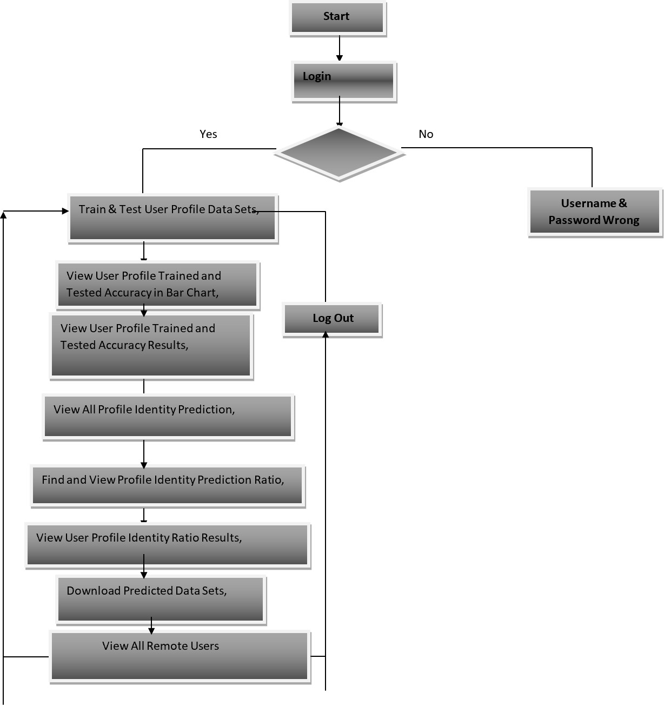

Fig no 4.3: Service provider
In fig 4.3 this flowchart illustrates the login process where users either gain access after successful authentication or receive an error for incorrect credentials. Upon successful login, users can train and test profile datasets, view prediction results and ratios, download predicted data, and manage remote users. The process ends with a logout option.

System Architecture:

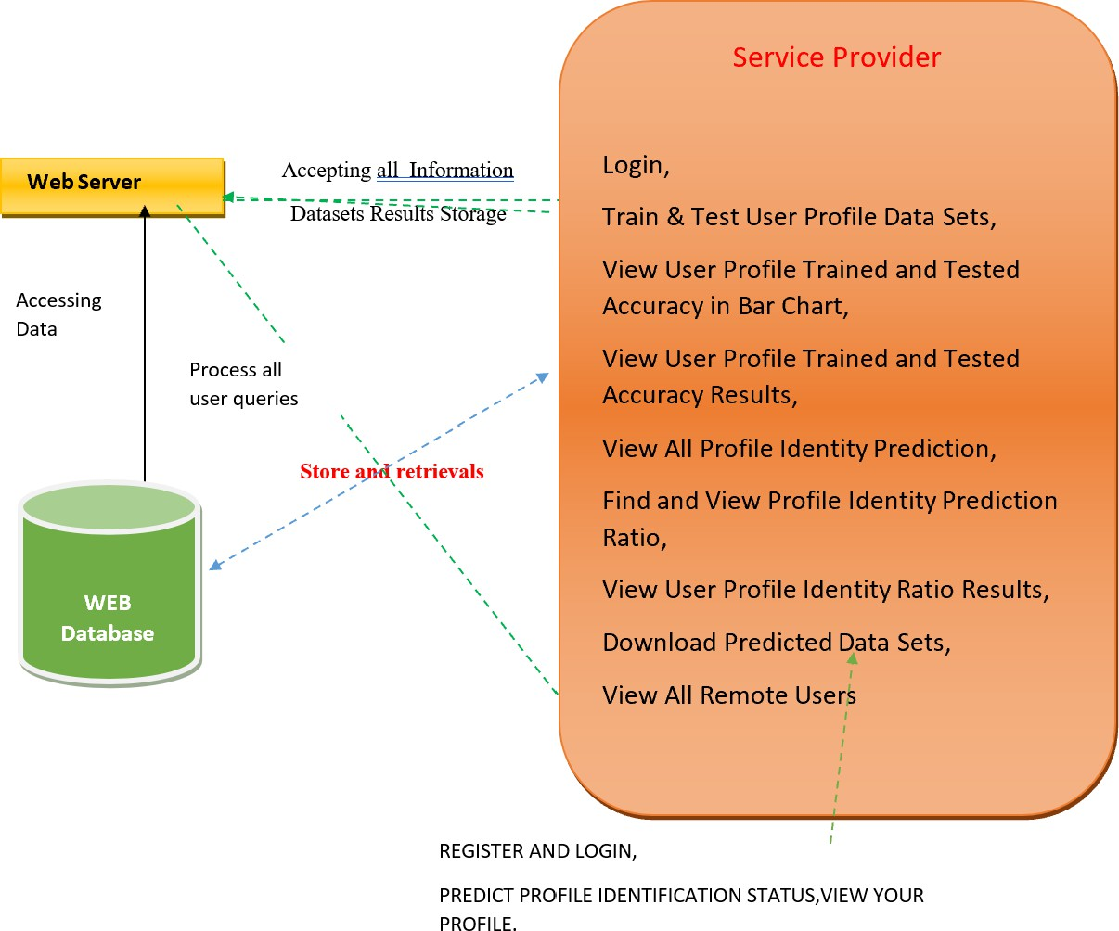

Fig no 4.4: System architecture
In fig 4.4 this diagram shows how a service provider interacts with a web server and database to manage user activities like login, profile training/testing, accuracy viewing, and downloading data. The server processes queries, stores results, and retrieves information from the database to support user operations.

UML Daigrams:
Class diagram:
The class diagram is used to refine the use case diagram and define a detailed design of the system. The class diagram classifies the actors defined in the use case diagram into a set of interrelated classes. The relationship or association between the classes can be either an "is-a" or "has-a" relationship. Each class in the class diagram may be capable of providing certain functionalities. These functionalities provided by the class are termed "methods" of the class. Apart from this, each class may have certain "attributes" that uniquely.
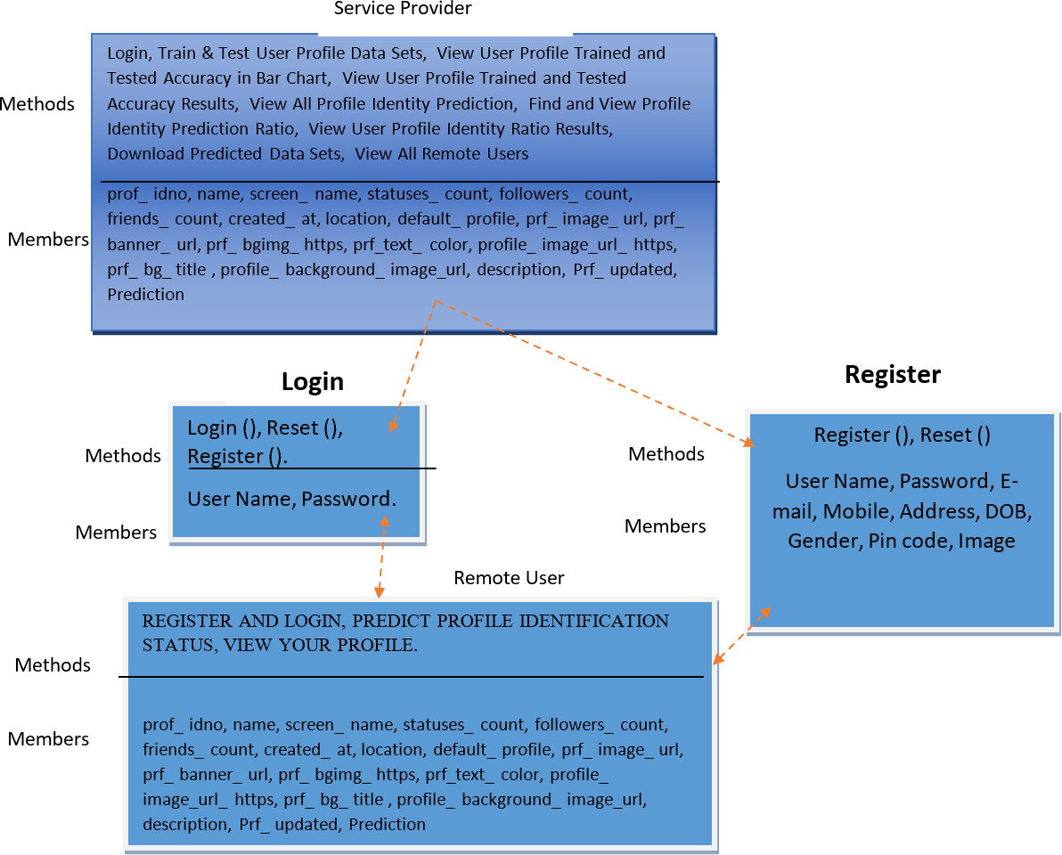

Fig no 4.5.1: Class diagram

In fig 4.5.1 this diagram shows the relationship between Service Provider and Remote User, where users can register, login, and reset credentials. After login, users can manage and view profile details and prediction statuses, while the service provider handles profile data operations like training, testing, accuracy checking, and predictions.

Use case Diagram:
A use case diagram in the Unified Modeling Language (UML) is a type of behavioral diagram defined by and created from a Use-case analysis. Its purpose is to present a graphical overview of the functionality provided by a system in terms of actors, their goals (represented as use cases), and any dependencies between those use cases. The main purpose of a use case diagram is to show what system functions are performed for which actor. Roles of the actors in the system can be depicted.

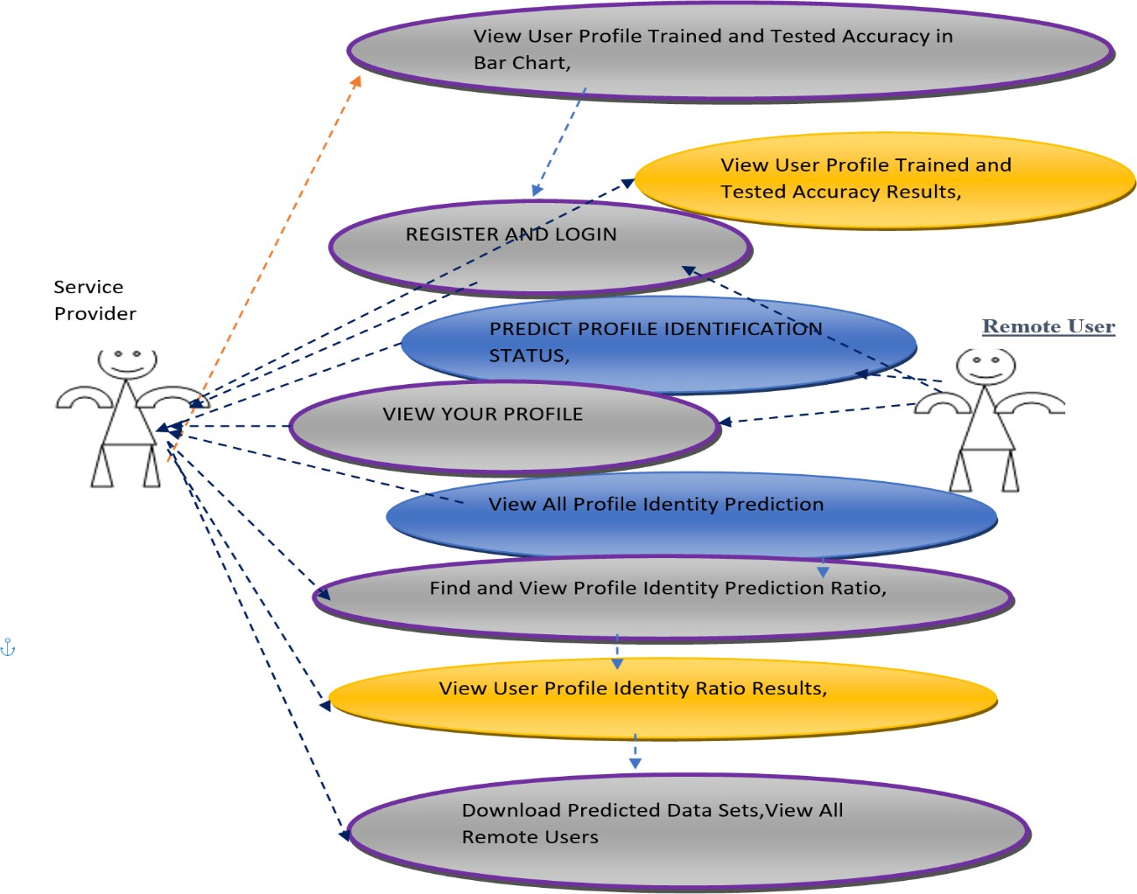
Fig no 4.5.2: Use case diagram

In fig 4.5.2 the diagram illustrates a service where a user can register and log in to view and predict their profile identity status. The service provider facilitates interactions between the user and remote users. Users can view their profile, predict profile identity status, and see accuracy results in bar charts. They can also download predicted data sets and view all remote users. The service allows users to find and view identity predictions and results, enhancing their understanding of profile accuracy.

Sequence Diagram:
A sequence diagram represents the interaction between different objects in the system. The important aspect of a sequence diagram is that it is time-ordered. This means that the exact sequence of the interactions between the objects is represented step by step. Different objects in the sequence diagram interact with each other by passing "messages".

Sequence Diagram
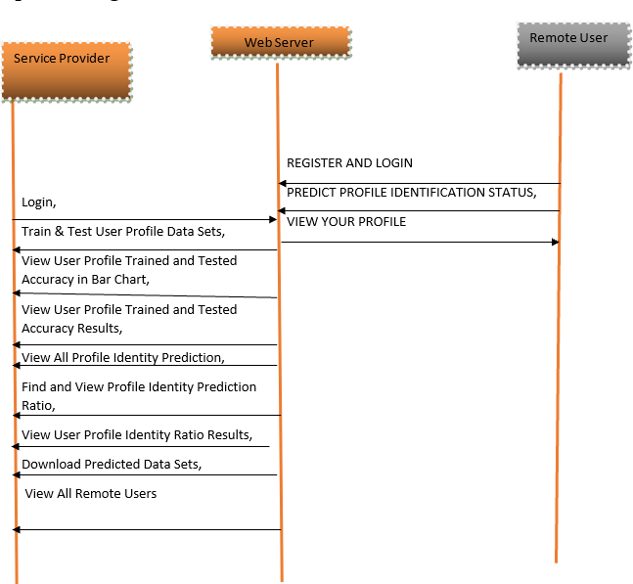
Fig no 4.5.3: Sequence diagram

In fig 4.5.3 the diagram shows a sequence of interactions between a service provider, web server, and remote user. The service provider allows users to log in, train and test their profile data, and view accuracy results. It also enables users to predict profile identification status, view their profiles, and download predicted data sets. Remote users can access these features through the web server, facilitating secure and efficient data processing and profile management.

Collaborative Diagram:
A collaboration diagram groups together the interactions between different objects. The interactions are listed as numbered interactions that help to trace the sequence of the interactions. The collaboration diagram helps to identify all the possible interactions that each object has with other objects.

1: Login
2: REGISTER AND LOGIN
4: PREDICT PROFILE IDENTIFICATION STATUS,
6: VIEW YOUR PROFILE

3: Train & Test User Profile Data Sets,
5: View User Profile Trained and Tested Accuracy in Bar Chart, 7: View User Profile Trained and Tested Accuracy Results,
8: View All Profile Identity Prediction,
9: Find and View Profile Identity Prediction Ratio, 10: View User Profile Identity Ratio Results,
11: Download Predicted Data Sets, 12: View All Remote Users
remote user
web server
service provider

Fig no 4.5.4: Collaborative diagram
In fig 4.5.4 the sequence diagram shows interactions between a service provider, web server, and remote user. The remote user logs in and performs various actions such as training and testing user profile data, viewing accuracy results, predicting profile identity status, and downloading data sets. The web server facilitates these interactions, allowing the remote user to access and manage their profile data securely.

Chapter-05

SYSTEM REQUIREMENTS

HARDWARE REQUIREMENTS:
- Processor - Pentium –IV
- RAM - 4 GB (min)
- Hard Disk - 20 GB
- Key Board - Standard Windows Keyboard
- Mouse - Two or Three Button Mouse
- Monitor - SVGA

  - SOFTWARE REQUIREMENTS:
- Operating system : Windows 7 Ultimate.
- Coding Language : Python.
- Front-End : Python.
- Back-End : Django-ORM
- Designing : Html, css, javascript.
- Data Base : MySQL (WAMP Server).

  - SOFTWARE FEATURES:
System Environment:
What is Python :-
Below are some facts about Python.
- Python is currently the most widely used multi-purpose, high-level programming language.
- Python allows programming in Object-Oriented and Procedural paradigms. Python programs generally are smaller than other programming languages like Java.
- Programmers have to type relatively less and indentation requirement of the language, makes them readable all the time.
- Python language is being used by almost all tech-giant companies like – Google, Amazon, Facebook, Instagram, Dropbox, Uber… etc.
- The biggest strength of Python is huge collection of standard library which can be used for the following .

Machine Learning
- GUI Applications (like Kivy, Tkinter, PyQt etc. )
- Web frameworks like Django (used by YouTube, Instagram, Dropbox)
- Image processing (like Opencv, Pillow)
- Web scraping (like Scrapy, BeautifulSoup, Selenium)
- Test frameworks
- Advantages of Python :-
- Let’s see how Python dominates over other languages.

Extensive Libraries
- Python downloads with an extensive library and it contain code for various purposes like regular expressions, documentation-generation, unit-testing, web browsers, threading, databases, CGI, email, image manipulation, and more. So, we don’t have to write the complete code for that manually.

Extensible
- As we have seen earlier, Python can be extended to other languages. You can write some of your code in languages like C++ or C. This comes in handy, especially in projects.

Embeddable
- Complimentary to extensibility, Python is embeddable as well. You can put your Python code in your source code of a different language, like C++. This lets us add scripting capabilities to our code in the other language.

Improved Productivity
- The language’s simplicity and extensive libraries render programmers more productive than languages like Java and C++ do. Also, the fact that you need to write less and get more things done.

IOT Opportunities
- Since Python forms the basis of new platforms like Raspberry Pi, it finds the future bright for the Internet Of Things. This is a way to connect the language with the real world.

Simple and Easy
- When working with Java, you may have to create a class to print ‘Hello World’. But in Python, just a print statement will do. It is also quite easy to learn, understand, and code. This is why when people pick up Python, they have a hard time adjusting to other more verbose languages like Java.

Readable
- Because it is not such a verbose language, reading Python is much like reading English. This is the reason why it is so easy to learn, understand, and code. It also does not need curly braces to define blocks, and indentation is mandatory. This further aids the readability of the code.

Object-Oriented
- This language supports both the procedural and object-oriented programming paradigms. While functions help us with code reusability, classes and objects let

us model the real world. A class allows the encapsulation of data and functions into one.

Advantages of Python Over Other Languages
- Less Coding
  - Almost all of the tasks done in Python requires less coding when the same task is done in other languages. Python also has an awesome standard library support, so you don’t have to search for any third-party libraries to get your job done. This is the reason that many people suggest learning Python to beginners.

Affordable
  - Python is free therefore individuals, small companies or big organizations can leverage the free available resources to build applications. Python is popular and widely used so it gives you better community support.
  - The 2019 Github annual survey showed us that Python has overtaken Java in the most popular programming language category.

Disadvantages of Python
So far, we’ve seen why Python is a great choice for your project. But if you choose it, you should be aware of its consequences as well. Let’s now see the downsides of choosing Python over another language.

Speed Limitations
  - We have seen that Python code is executed line by line. But since Python is interpreted, it often results in slow execution. This, however, isn’t a problem unless speed is a focal point for the project. In other words, unless high speed is a requirement, the benefits offered by Python are enough to distract us from its speed limitations.

Weak in Mobile Computing and Browsers
  - While it serves as an excellent server-side language, Python is much rarely seen on the client-side. Besides that, it is rarely ever used to implement smartphone- based applications. One such application is called Carbonnelle.

  - The reason it is not so famous despite the existence of Brython is that it isn’t that secure.

Underdeveloped Database Access Layers
  - Compared to more widely used technologies like JDBC (Java DataBase Connectivity) and ODBC (Open DataBase Connectivity), Python’s database access layers are a bit underdeveloped. Consequently, it is less often applied in huge enterprises.

What is Machine Learning : -
Before we take a look at the details of various machine learning methods, let's start by looking at what machine learning is, and what it isn't. Machine learning is often categorized as a subfield of artificial intelligence, but I find that categorization can often be misleading at first brush. The study of machine learning certainly arose from research in this context, but in the data science application of machine learning methods, it's more helpful to think of machine learning as a means of building models of data.
Fundamentally, machine learning involves building mathematical models to help understand data. "Learning" enters the fray when we give these models tunable parameters that can be adapted to observed data; in this way the program can be considered to be "learning" from the data.
Once these models have been fit to previously seen data, they can be used to predict and understand aspects of newly observed data. I'll leave to the reader the more philosophical digression regarding the extent to which this type of mathematical, model-based "learning" is similar to the "learning" exhibited by the human brain.

Categories Of Machine Leaning :-
At the most fundamental level, machine learning can be categorized into two main types: supervised learning and unsupervised learning.
  - Supervised learning involves somehow modeling the relationship between measured features of data and some label associated with the data; once this model is determined, it can be used to apply labels to new, unknown data. This

is further subdivided into classification tasks and regression tasks: in classification, the labels are discrete categories, while in regression, the labels are continuous quantities. We will see examples of both types of supervised learning in the following section.
  - Unsupervised learning involves modeling the features of a dataset without reference to any label, and is often described as "letting the dataset speak for itself." These models include tasks such as clustering and dimensionality reduction.
  - Clustering algorithms identify distinct groups of data, while dimensionality reduction algorithms search for more succinct representations of the data. We will see examples of both types of unsupervised learning in the following section.

Need for Machine Learning
Human beings, at this moment, are the most intelligent and advanced species on earth because ssthey can think, evaluate and solve complex problems. On the other side, AI is still in its initial stage and haven’t surpassed human intelligence in many aspects
Lately, organizations are investing heavily in newer technologies like Artificial Intelligence, Machine Learning and Deep Learning to get the key information from data to perform several real-world tasks and solve problems. We can call it data-driven decisions taken by machines, particularly to automate the process.

Challenges in Machines Learning :−
  - Quality of data − Having good-quality data for ML algorithms is one of the biggest challenges. Use of low-quality data leads to the problems related to data preprocessing and feature extraction.
  - Time-Consuming task − Another challenge faced by ML models is the consumption of time especially for data acquisition, feature extraction and retrieval.
  - Lack of specialist persons − As ML technology is still in its infancy stage, availability of expert resources is a tough job.
  - Difficulty in deployment − Complexity of the ML model makes it quite difficult to be deployed in real life.

Chapter-06

APPLICATIONS

Applications of Machines Learning :-
Machine Learning is the most rapidly growing technology and according to researchers we are in the golden year of AI and ML. It is used to solve many real- world complex problems which cannot be solved with traditional approach. Following are some real-world applications of ML −
    - Emotion analysis
    - Sentiment analysis
    - Error detection and prevention
    - Weather forecasting and prediction
    - Stock market analysis and forecasting
    - Speech synthesis
    - Speech recognition
    - Customer segmentation
    - Object recognition
    - Fraud detection
    - Fraud prevention
    - Recommendation of products to customer in online shopping

How to Start Learning Machine Learning?
Arthur Samuel coined the term “Machine Learning” in 1959 and defined it as a “Field of study that gives computers the capability to learn without being explicitly programmed”.
    - And that was the beginning of Machine Learning! In modern times, Machine Learning is one of the most popular (if not the most!) career choices. According to Indeed, Machine Learning Engineer Is The Best Job of 2019 with a 344% growth and an average base salary of $146,085 per year.

    - But there is still a lot of doubt about what exactly is Machine Learning and how to start learning it? So this article deals with the Basics of Machine Learning and also the path you can follow to eventually become a full-fledged Machine Learning Engineer. Now let’s get started!!!

How to start learning ML?
This is a rough roadmap you can follow on your way to becoming an insanely talented Machine Learning Engineer. Of course, you can always modify the steps according to your needs to reach your desired end-goal!
Step 1 – Understand the Prerequisites
In case you are a genius, you could start ML directly but normally, there are some prerequisites that you need to know which include Linear Algebra, Multivariate Calculus, Statistics, and Python. And if you don’t know these, never fear! You don’t need a Ph.D. degree in these topics to get started but you do need a basic understanding.

Learn Linear Algebra and Multivariate Calculus
Both Linear Algebra and Multivariate Calculus are important in Machine Learning. However, the extent to which you need them depends on your role as a data scientist. If you are more focused on application heavy machine learning, then you will not be that heavily focused on maths as there are many common libraries available. But if you want to focus on R&D in Machine Learning, then mastery of Linear Algebra and Multivariate Calculus is very important as you will have to implement many ML algorithms from scratch.

Learn Statistics
Data plays a huge role in Machine Learning. In fact, around 80% of your time as an ML expert will be spent collecting and cleaning data. And statistics is a field that handles the collection, analysis, and presentation of data. Some of the key concepts in statistics that are important are Statistical Significance, Probability Distributions, Hypothesis Testing, Regression, etc. Also, Bayesian Thinking is also a very important part of ML which deals with various concepts like Conditional Probability, Priors, and Posteriors, Maximum Likelihood, etc.

Learn Python
Some people prefer to skip Linear Algebra, Multivariate Calculus and Statistics and learn them as they go along with trial and error. But the one thing that you absolutely cannot skip is Python! While there are other languages you can use for Machine Learning like R, Scala, etc. Python is currently the most popular language for ML. In fact, there are many Python libraries that are specifically useful for Artificial Intelligence and Machine Learning such as Keras, TensorFlow, Scikit- learn, etc.
So if you want to learn ML, it’s best if you learn Python! You can do that using various online resources and courses such as Fork Python available Free on GeeksforGeeks.

6.3.2 Step 2 – Learn Various ML Concepts
Now that you are done with the prerequisites, you can move on to actually learning ML (Which is the fun part!!!) It’s best to start with the basics and then move on to the more complicated stuff. Some of the basic concepts in ML are:

(a) Terminologies of Machine Learning
- Model – A model is a specific representation learned from data by applying some machine learning algorithm. A model is also called a hypothesis.
- Feature – A feature is an individual measurable property of the data. A set of numeric features can be conveniently described by a feature vector. Feature vectors are fed as input to the model. For example, in order to predict a fruit, there may be features like color, smell, taste, etc.
- Target (Label) – A target variable or label is the value to be predicted by our model. For the fruit example discussed in the feature section, the label with each set of input would be the name of the fruit like apple, orange, banana, etc.
- Training – The idea is to give a set of inputs(features) and it’s expected outputs(labels), so after training, we will have a model (hypothesis) that will then map new data to one of the categories trained on.
- Prediction – Once our model is ready, it can be fed a set of inputs to which it will provide a predicted output(label).

(b) Types of Machine Learning
- Supervised Learning – This involves learning from a training dataset with labeled data using classification and regression models. This learning process continues until the required level of performance is achieved.
- Unsupervised Learning – This involves using unlabeled data and then finding the underlying structure in the data in order to learn more and more about the data itself using factor and cluster analysis models.
- Semi-supervised Learning – This involves using unlabeled data like Unsupervised Learning with a small amount of labeled data. Using labeled data vastly increases the learning accuracy and is also more cost-effective than Supervised Learning.
- Reinforcement Learning – This involves learning optimal actions through trial and error. So the next action is decided by learning behaviors that are based on the current state and that will maximize the reward in the future.

Advantages of Machine learning :-
- Easily identifies trends and patterns -
Machine Learning can review large volumes of data and discover specific trends and patterns that would not be apparent to humans. For instance, for an e- commerce website like Amazon, it serves to understand the browsing behaviors and purchase histories of its users to help cater to the right products, deals, and reminders relevant to them. It uses the results to reveal relevant advertisements to them.

No human intervention needed (automation)
With ML, you don’t need to babysit your project every step of the way. Since it means giving machines the ability to learn, it lets them make predictions and also improve the algorithms on their own. A common example of this is anti-virus softwares; they learn to filter new threats as they are recognized. ML is also good at recognizing spam.

Continuous Improvement
As ML algorithms gain experience, they keep improving in accuracy and efficiency. This lets them make better decisions. Say you need to make a weather forecast model. As the amount of data you have keeps growing, your algorithms learn to make more accurate predictions faster.

Handling multi-dimensional and multi-variety data
Machine Learning algorithms are good at handling data that are multi- dimensional and multi-variety, and they can do this in dynamic or uncertain environments.

Disadvantages of Machine Learning :-
- Data Acquisition
Machine Learning requires massive data sets to train on, and these should be inclusive/unbiased, and of good quality. There can also be times where they must wait for new data to be generated.

Time and Resources
ML needs enough time to let the algorithms learn and develop enough to fulfill their purpose with a considerable amount of accuracy and relevancy. It also needs massive resources to function. This can mean additional requirements of computer power for you.

Interpretation of Results
Another major challenge is the ability to accurately interpret results generated by the algorithms. You must also carefully choose the algorithms for your purpose.

Python Development Steps : -
Guido Van Rossum published the first version of Python code (version 0.9.0) at sources in February 1991. This release included already exception handling, functions, and the core data types of list, dict, str and others. Python version 1.0 was released in January 1994. The major new features included in this release were the functional programming tools lambda, map, filter and reduce, which Guido Van Rossum never liked. Six and a half years later in October 2000, Python 2.0 was introduced. This release included list comprehensions, a full garbage collector and it was supporting unicode.Python flourished for another 8 years in the versions 2.x

before the next major release as Python 3.0 (also known as "Python 3000" and "Py3K") was released. Python 3 is not backwards compatible with Python 2.x.
The emphasis in Python 3 had been on the removal of duplicate programming constructs and modules, thus fulfilling or coming close to fulfilling the 13th law of the Zen of Python: "There should be one -- and preferably only one -- obvious way to do it."Some changes in Python 7.3:
  - Print is now a function
  - Views and iterators instead of lists
  - The rules for ordering comparisons have been simplified. E.g. a heterogeneous list cannot be sorted, because all the elements of a list must be comparable to each other.
  - There is only one integer type left, i.e. int. long is int as well.
  - The division of two integers returns a float instead of an integer. "//" can be used to have the "old" behaviour.
  - Text Vs. Data Instead Of Unicode Vs. 8-bit

Purpose :-
We demonstrated that our approach enables successful segmentation of intra- retinal layers—even with low-quality images containing speckle noise, low contrast, and different intensity ranges throughout—with the assistance of the ANIS feature.

Chapter-07

Tensorflow

MODULES USED

    - TensorFlow is a free and open-source software library for dataflow and differentiable programming across a range of tasks. It is a symbolic math library, and is also used for machine learning applications such as neural networks. It is used for both research and production at Google.
    - TensorFlow was developed by the Google Brain team for internal Google use. It was released under the Apache 2.0 open-source license on November 9, 2015.

Numpy
    - Numpy is a general-purpose array-processing package. It provides a high- performance multidimensional array object, and tools for working with these arrays.
    - It is the fundamental package for scientific computing with Python. It contains various features including these important ones:
    - A powerful N-dimensional array object
    - Sophisticated (broadcasting) functions
    - Tools for integrating C/C++ and Fortran code
    - Useful linear algebra, Fourier transform, and random number capabilities
    - Besides its obvious scientific uses, Numpy can also be used as an efficient multi- dimensional container of generic data. Arbitrary data-types can be defined using Numpy which allows Numpy to seamlessly and speedily integrate with a wide variety of databases.

Pandas
    - Pandas is an open-source Python Library providing high-performance data manipulation and analysis tool using its powerful data structures. Python was majorly used for data munging and preparation. It had very little contribution

towards data analysis. Pandas solved this problem. Using Pandas, we can accomplish five typical steps in the processing and analysis of data, regardless of the origin of data load, prepare, manipulate, model, and analyze. Python with Pandas is used in a wide range of fields including academic and commercial domains including finance, economics, Statistics, analytics, etc.

Matplotlib
Matplotlib is a Python 2D plotting library which produces publication quality figures in a variety of hardcopy formats and interactive environments across platforms. Matplotlib can be used in Python scripts, the Python and IPython shells, the Jupyter Notebook, web application servers, and four graphical user interface toolkits. Matplotlib tries to make easy things easy and hard things possible. You can generate plots, histograms, power spectra, bar charts, error charts, scatter plots, etc., with just a few lines of code. For examples, see the sample plots and thumbnail gallery.
For simple plotting the pyplot module provides a MATLAB-like interface, particularly when combined with IPython. For the power user, you have full control of line styles, font properties, axes properties, etc, via an object oriented interface or via a set of functions familiar to MATLAB users.

Scikit – learn
    - Scikit-learn provides a range of supervised and unsupervised learning algorithms via a consistent interface in Python. It is licensed under a permissive simplified BSD license and is distributed under many Linux distributions, encouraging academic and commercial use. Python
    - Python is an interpreted high-level programming language for general-purpose programming. Created by Guido van Rossum and first released in 1991, Python has a design philosophy that emphasizes code readability, notably using significant whitespace.
    - Python is Interpreted − Python is processed at runtime by the interpreter. You do not need to compile your program before executing it. This is similar to PERL and PHP.

Chapter-08

ALGORITHM

K-NearestNeighbors (KNN)
    - Simple, but a very powerful classification algorithm

    - Classifies based on a similarity measure
    - Non-parametric
    - Lazy learning
    - Does not “learn” until the test example is given
    - Whenever we have a new data to classify, we find its K-nearest neighbors from the training data

Example

    - Training dataset consists of k-closest examples in feature space
    - Feature space means, space with categorization variables (non-metric variables)
    - Learning based on instances, and thus also works lazily because instance close to the input vector for test or prediction may take time to occur in the training dataset

Logistic regression Classifiers
Logistic regression analysis studies the association between a categorical dependent variable and a set of independent (explanatory) variables. The name logistic regression is used when the dependent variable has only two values, such as 0 and 1 or Yes and No. The name multinomial logistic regression is usually reserved for the case when the dependent variable has three or more unique values, such as Married, Single, Divorced, or Widowed. Although the type of data used for the dependent variable is different from that of multiple regression, the practical use of the procedure is similar.
Logistic regression competes with discriminant analysis as a method for analyzing categorical-response variables. Many statisticians feel that logistic

regression is more versatile and better suited for modeling most situations than is discriminant analysis. This is because logistic regression does not assume that the independent variables are normally distributed, as discriminant analysis does.

Naive Bayes
The naive bayes approach is a supervised learning method which is based on a simplistic hypothesis: it assumes that the presence (or absence) of a particular feature of a class is unrelated to the presence (or absence) of any other feature .
Yet, despite this, it appears robust and efficient. Its performance is comparable to other supervised learning techniques. Various reasons have been advanced in the literature. In this tutorial, we highlight an explanation based on the representation bias. The naive bayes classifier is a linear classifier, as well as linear discriminant analysis, logistic regression or linear SVM (support vector machine). The difference lies on the method of estimating the parameters of the classifier (the learning bias).

While the Naive Bayes classifier is widely used in the research world, it is not widespread among practitioners which want to obtain usable results. On the one hand, the researchers found especially it is very easy to program and implement it, its parameters are easy to estimate, learning is very fast even on very large databases, its accuracy is reasonably good in comparison to the other approaches. On the other hand, the final users do not obtain a model easy to interpret and deploy, they does not understand the interest of such a technique.

Random Forest
Random forests or random decision forests are an ensemble learning method for classification, regression and other tasks that operates by constructing a multitude of decision trees at training time. For classification tasks, the output of the random forest is the class selected by most trees. For regression tasks, the mean or average prediction of the individual trees is returned. Random decision forests correct for decision trees' habit of overfitting to their training set. Random forests generally outperform decision trees, but their accuracy is lower than gradient boosted trees. However, data characteristics can affect their performance.

SVM
In classification tasks, discriminant machine learning techniques are designed to find a function that accurately predicts the label or class of new, unseen instances. These methods operate by learning from a training dataset that is assumed to be independent and identically distributed (i.i.d.). The goal is to construct a discriminant function that directly maps input data points (denoted as x) to specific output classes without explicitly modeling the underlying probability distributions.
Discriminant approaches focus purely on decision boundaries between classes. They do not require estimating the full probability distribution of the data, which simplifies computation and often leads to faster training and prediction times. Examples of discriminant models include Support Vector Machines (SVM), Logistic Regression, and Discriminant Analysis (such as Linear Discriminant Analysis, LDA).
In contrast, generative machine learning approaches (like Naive Bayes or Gaussian Mixture Models) attempt to model how the data is generated by estimating the conditional probability distributions (e.g., P(x∣y)P(x|y)P(x∣y) and P(y)P(y)P(y)). From these models, predictions can be made by applying Bayes’ theorem. Generative models are often more powerful because they capture a deeper understanding of the data structure. They are particularly useful when the classification task involves outlier detection, anomaly detection, or when the distribution of data is complex and informative.
However, discriminant techniques have their advantages: they tend to be more robust, easier to implement, and efficient, especially when the goal is pure classification rather than data generation or anomaly detection. They directly optimize for classification accuracy, making them the preferred choice in many real- world scenarios where the primary focus is correct labeling rather than understanding the full data distribution.

Chapter-09

INSTALL PYTHON STEP-BY-STEP IN WINDOWS AND MAC
- Python a versatile programming language doesn’t come pre-installed on your computer devices. Python was first released in the year 1991 and until today it is a very popular high-level programming language. Its style philosophy emphasizes code readability with its notable use of great whitespace.
- The object-oriented approach and language construct provided by Python enables programmers to write both clear and logical code for projects. This software does not come pre-packaged with Windows.

How to Install Python on Windows and Mac
There have been several updates in the Python version over the years. The question is how to install Python? It might be confusing for the beginner who is willing to start learning Python but this tutorial will solve your query. The latest or the newest version of Python is version 3.7.4 or in other words, it is Python 3.
Note: The python version 3.7.4 cannot be used on Windows XP or earlier devices.
Step 1: Go to the official site to download and install python using Google Chrome or any other web browser. OR Click on the following link: https://www.python.org
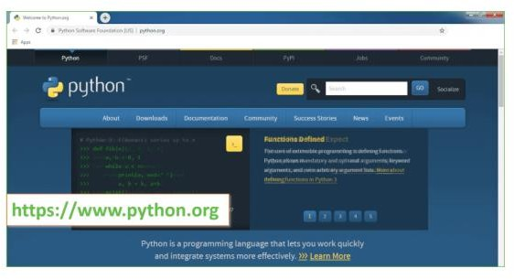
    - Now, check for the latest and the correct version for your operating system.

Step 2: Click on the Download Tab.
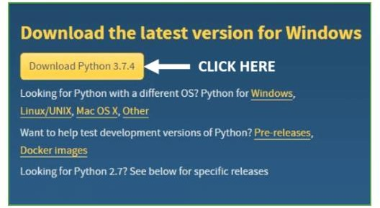

Step 3: You can either select the Download Python for windows 3.7.4 button in Yellow Color or you can scroll further down and click on download with respective to their version. Here, we are downloading the most recent python version for windows 3.7.4
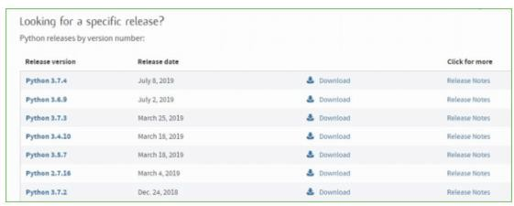
Step 4: Scroll down the page until you find the Files option.

Step 5: Here you see a different version of python along with the operating system.

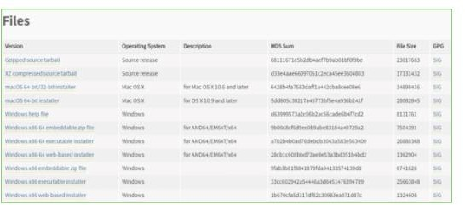

    - To download Windows 32-bit python, you can select any one from the three options: Windows x86 embeddable zip file, Windows x86 executable installer or Windows x86 web-based installer.
    - To download Windows 64-bit python, you can select any one from the three options: Windows x86-64 embeddable zip file, Windows x86-64 executable installer or Windows x86-64 web-based installer.
    - Here we will install Windows x86-64 web-based installer. Here your first part regarding which version of python is to be downloaded is completed. Now we move ahead with the second part in installing python i.e. Installation
Note: To know the changes or updates that are made in the version you can click on the Release Note Option.

Installation of Python
Step 1: Go to Download and Open the downloaded python version to carry out the installation process.
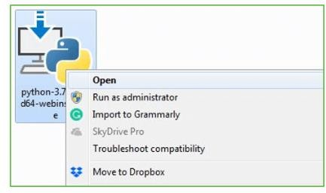

Step 2: Before you click on Install Now, Make sure to put a tick on Add Python 3.7 to PATH.
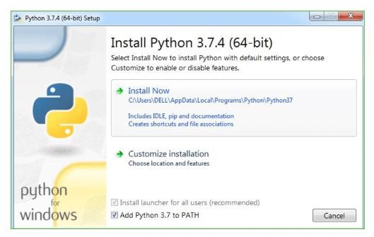

Step 3: Click on Install NOW After the installation is successful. Click on Close.
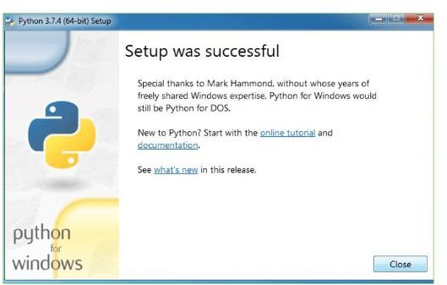
With these above three steps on python installation, you have successfully and correctly installed Python. Now is the time to verify the installation.
Note: The installation process might take a couple of minutes.
  - Verify the Python Installation Step 1: Click on Start
Step 2: In the Windows Run Command, type “cmd”.
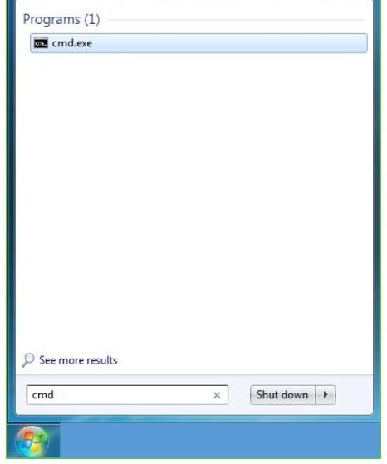
Step 3: Open the Command prompt option.

Step 4: Let us test whether the python is correctly installed. Type python –V and press Enter.
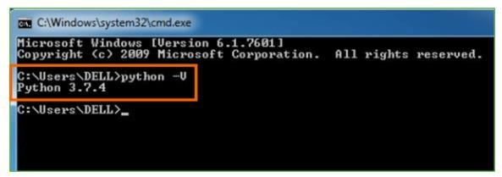

Step 5: You will get the answer as 3.7.4
Note: If you have any of the earlier versions of Python already installed. You must first uninstall the earlier version and then install the new one.
  - Check how the Python IDLE works Step 1: Click on Start

Step 2: In the Windows Run command, type “python idle”.
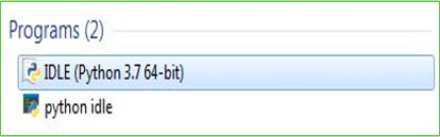

Step 3: Click on IDLE (Python 3.7 64-bit) and launch the program
Step 4: To go ahead with working in IDLE you must first save the file. Click on File > Click on Save

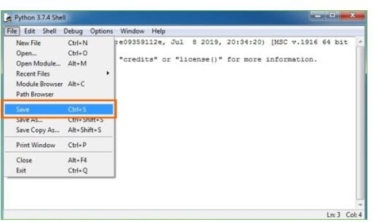

Chapter-10

SYSTEM TEST

SYSTEM TEST

The purpose of testing is to discover errors. Testing is the process of trying to discover every conceivable fault or weakness in a work product. It provides a way to check the functionality of components, sub assemblies, assemblies and/or a finished product It is the process of exercising software with the intent of ensuring that the Software system meets its requirements and user expectations and does not fail in an unacceptable manner. There are various types of test. Each test type addresses a specific testing requirement.

TYPES OF TESTS

Unit testing
Unit testing involves the design of test cases that validate that the internal program logic is functioning properly, and that program inputs produce valid outputs. All decision branches and internal code flow should be validated. It is the testing of individual software units of the application .it is done after the completion of an individual unit before integration. This is a structural testing, that relies on knowledge of its construction and is invasive. Unit tests perform basic tests at component level and test a specific business process, application, and/or system configuration. Unit tests ensure that each unique path of a business process performs accurately to the documented specifications and contains clearly defined inputs and expected results.

Integration testing
Integration tests are designed to test integrated software components to determine if they actually run as one program. Testing is event driven and is more concerned with the basic outcome of screens or fields. Integration tests demonstrate that although the components were individually satisfaction, as shown by successfully unit testing, the combination of components is correct and consistent. Integration testing is specifically aimed at exposing the problems that arise from the combination of components.

Functional test
Functional tests provide systematic demonstrations that functions tested are available as specified by the business and technical requirements, system documentation, and user manuals.
Functional testing is centered on the following items:
- Valid Input : identified classes of valid input must be accepted.
- Invalid Input : identified classes of invalid input must be rejected.
- Functions : identified functions must be exercised.
- Output : identified classes of application outputs must be exercised.
- Systems/Procedures : interfacing systems or procedures must be invoked.
Organization and preparation of functional tests is focused on requirements, key functions, or special test cases. In addition, systematic coverage pertaining to identify Business process flows; data fields, predefined processes, and successive processes must be considered for testing. Before functional testing is complete, additional tests are identified and the effective value of current tests is determined.

System Test
System testing ensures that the entire integrated software system meets requirements. It tests a configuration to ensure known and predictable results. An example of system testing is the configuration oriented system integration test. System testing is based on process descriptions and flows, emphasizing pre-driven process links and integration points.

White Box Testing
White Box Testing is a testing in which in which the software tester has knowledge of the inner workings, structure and language of the software, or at least its purpose. It is purpose. It is used to test areas that cannot be reached from a black box level.

Black Box Testing
Black Box Testing is testing the software without any knowledge of the inner workings, structure or language of the module being tested. Black box tests, as most other kinds of tests, must be written from a definitive source document, such as specification or requirements document, such as specification or requirements document. It is a testing in which the software under test is treated, as a black box
.you cannot “see” into it. The test provides inputs and responds to outputs without considering how the software works.

Unit Testing
Unit testing is usually conducted as part of a combined code and unit test phase of the software lifecycle, although it is not uncommon for coding and unit testing to be conducted as two distinct phases.

Test strategy and approach
Field testing will be performed manually and functional tests will be written in detail.

Test objectives
All field entries must work properly.
    - Pages must be activated from the identified link.
    - The entry screen, messages and responses must not be delayed.

Features to be tested
    - Verify that the entries are of the correct format
    - No duplicate entries should be allowed
    - All links should take the user to the correct page.

Integration Testing
Software integration testing is the incremental integration testing of two or more integrated software components on a single platform to produce failures caused by interface defects.

The task of the integration test is to check that components or software applications, e.g. components in a software system or – one step up – software applications at the company level – interact without error.
Test Results: All the test cases mentioned above passed successfully. No defects encountered.

Acceptance Testing
User Acceptance Testing is a critical phase of any project and requires significant participation by the end user. It also ensures that the system meets the functional requirements.
Test Results: All the test cases mentioned above passed successfully. No defects encountered.
Test cases1:
Test case for Login form:

- FUNCTION: | - LOGIN
- EXPECTED RESULTS: | - Should Validate the user and check his existence in database
- ACTUAL RESULTS: | - Validate the user and checking the user against the database
- LOW PRIORITY | - No
- HIGH PRIORITY | - Yes

Test case2:
    - Test case for User Registration form:

- FUNCTION: | - USER REGISTRATION
- EXPECTED RESULTS: | - Should check if all the fields are filled by the user and saving the user to database.
- ACTUAL RESULTS: | - Checking whether all the fields are field by user or not through validations and saving user.
- LOW PRIORITY | - No
- HIGH PRIORITY | - Yes

Test case3:
    - Test case for Change Password:
When the old password does not match with the new password ,then this results in displaying an error message as “ OLD PASSWORD DOES NOT MATCH WITH THE NEW PASSWORD”.

- FUNCTION: | - Change Password
- EXPECTED RESULTS: | - Should check if old password and new password fields are filled by the user and saving the user to database.
- ACTUAL RESULTS: | - Checking whether all the fields are field by user or not through validations and saving user.
- LOW PRIORITY | - No
- HIGH PRIORITY | - Yes

Chapter-11

SCREENSHOT

Service provider interface:
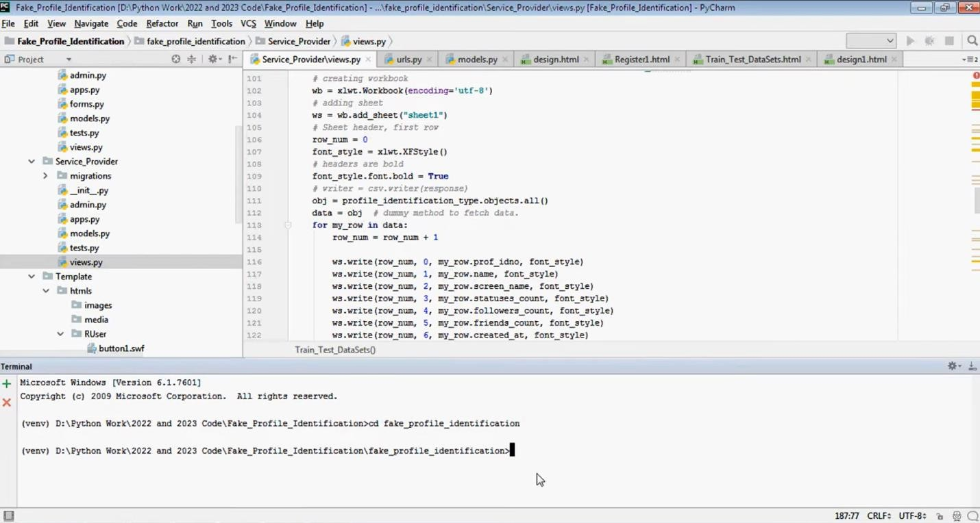
Fig no 11.1 Service Provider

Login Page:
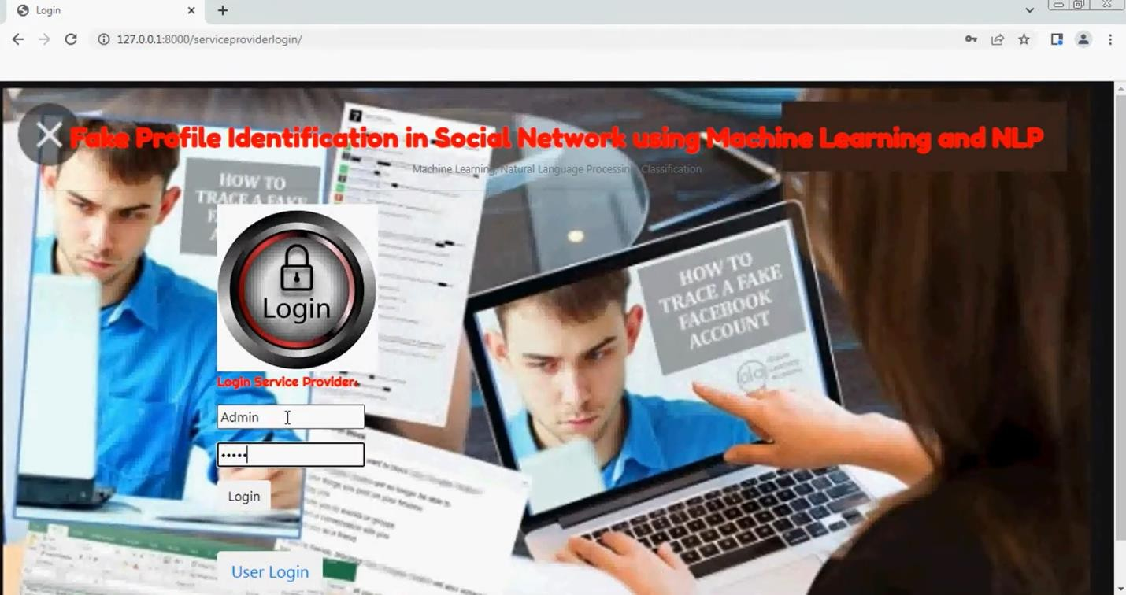
Fig no 11.2: Login page

Logout Page:
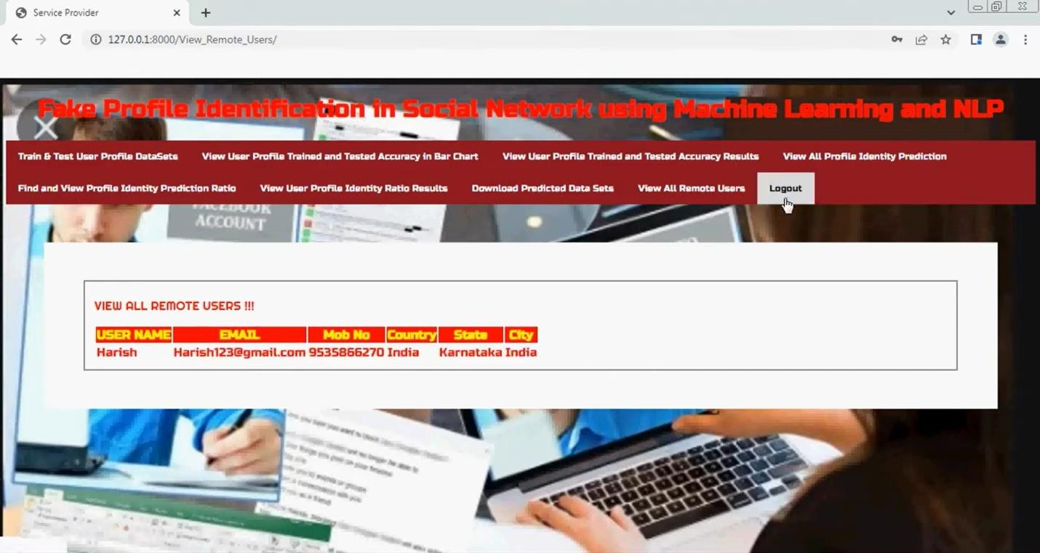
Fig no. 11.3: Logout page

Sign up Page:

Fig no. 11.4: Signup page

User Profile Trained and Accuracy:
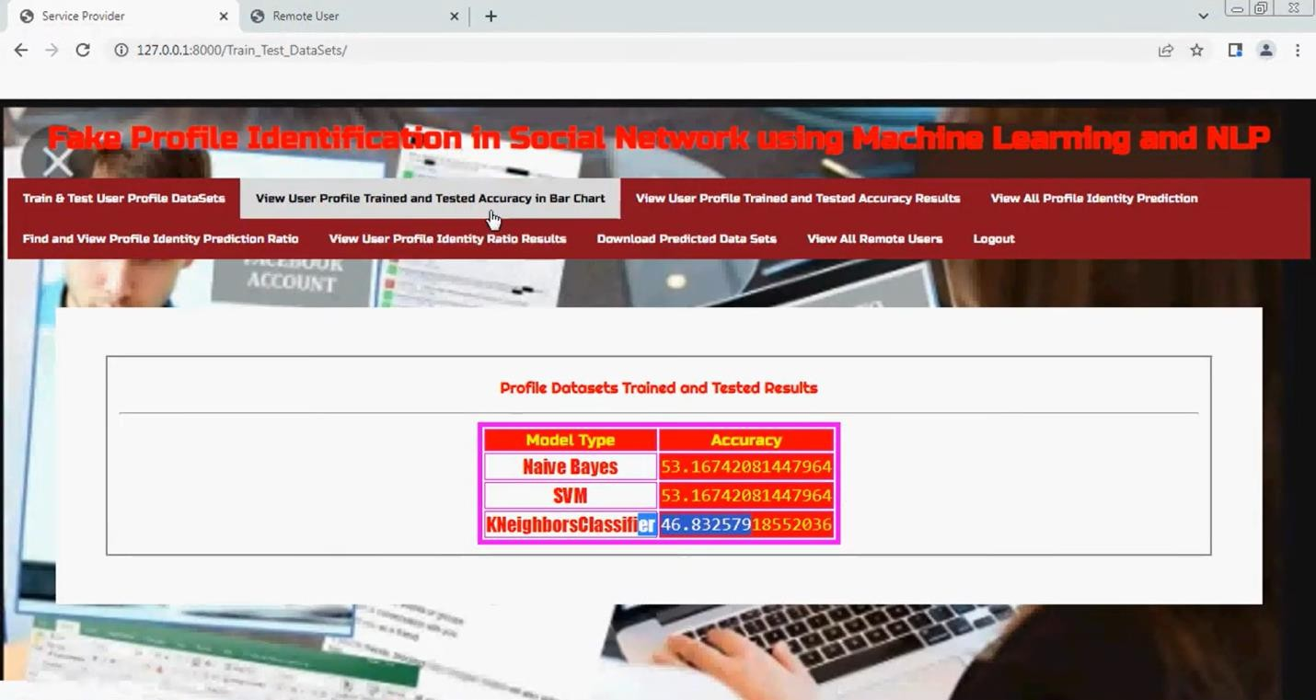
Fig no 11.5: User profile trained and accuracy

Profile Identification Status:
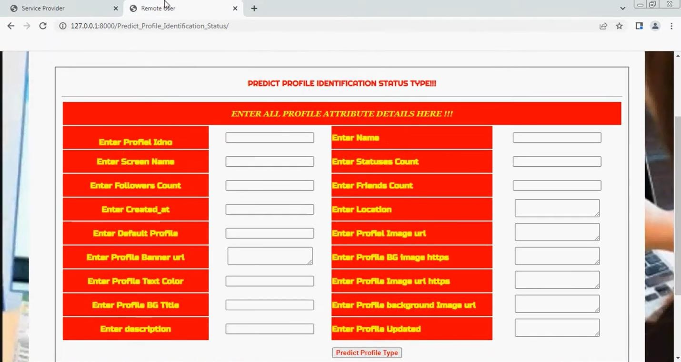
Fig no 11.6: Profile identification status

Profile Identification Status:
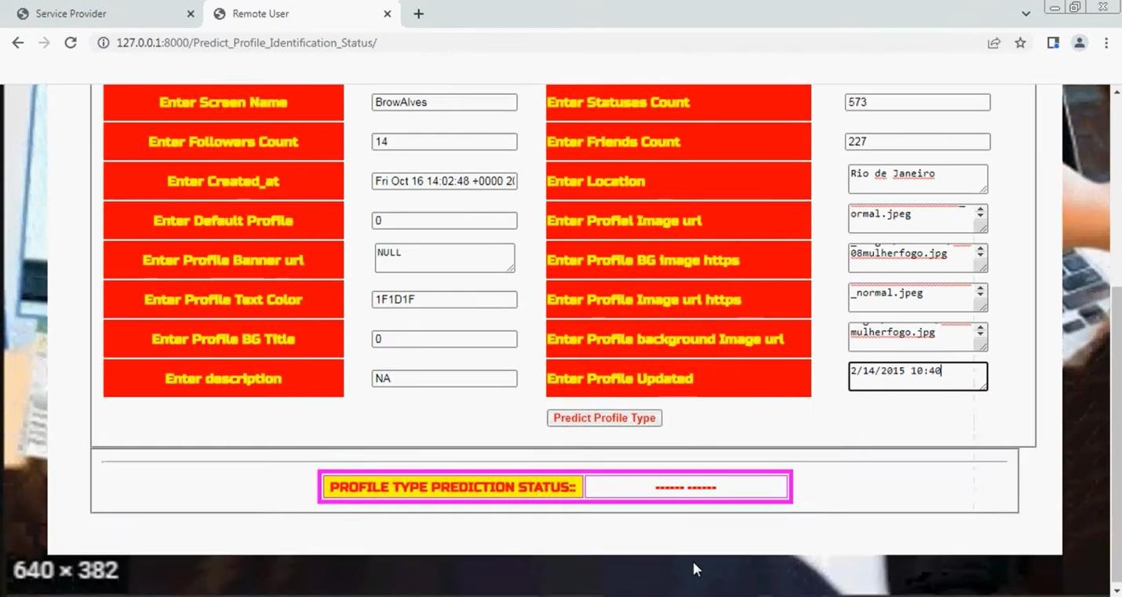
Fig no. 11.7: Profile identification status

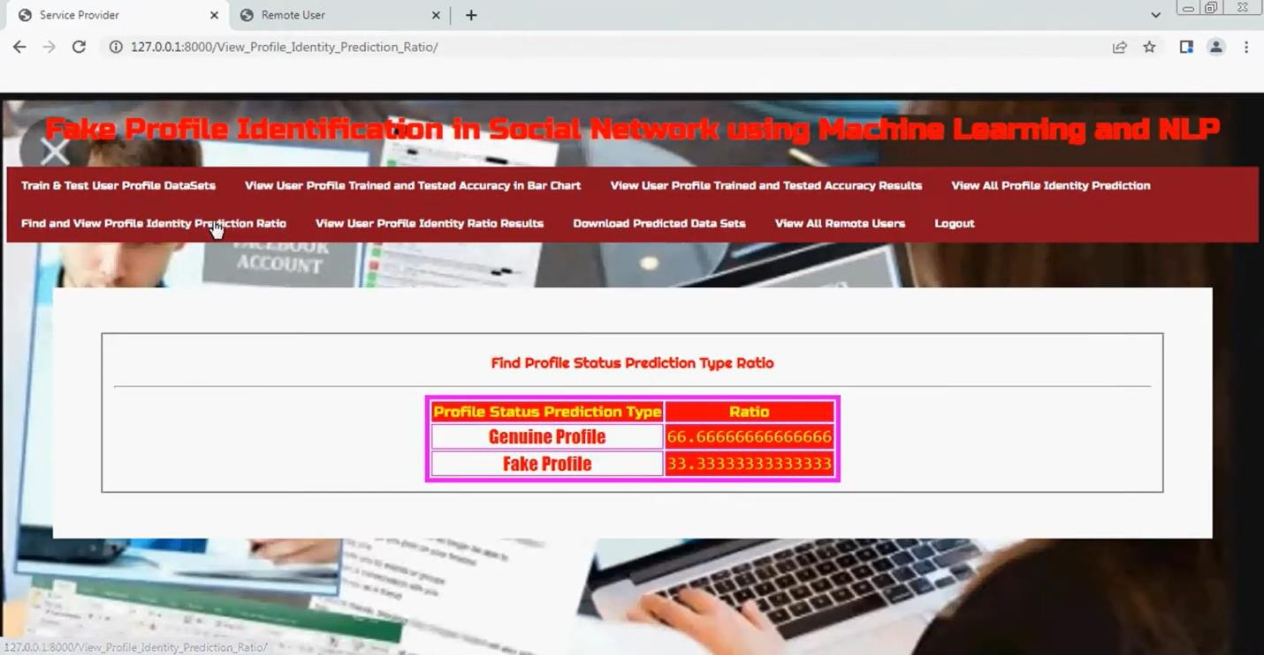
Prediction ratio
Fig no 11.8: Prediction ratio

Profile Status:
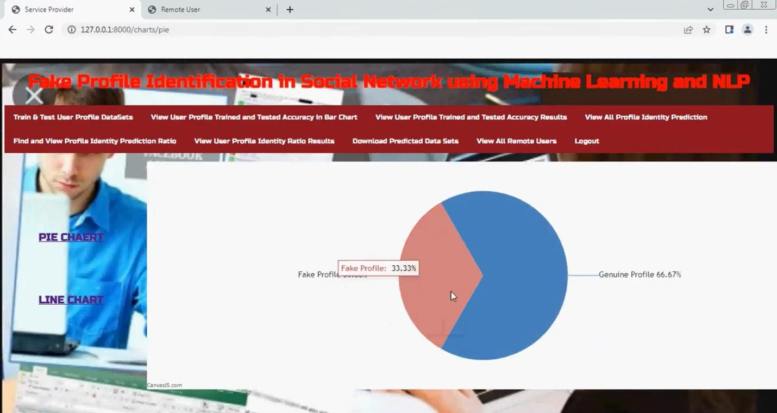
Fig no. 11.9: Profile status

Chapter -12

RESULT AND ANALYSIS

Our system robustly fulfills all functional requirements, allowing users to register, log in, submit a Twitter handle for analysis, view predictions distinguishing fake from genuine accounts, and download the annotated dataset. All UI workflows were rigorously tested through integration and acceptance testing with zero defects reported, ensuring a seamless user experience. Algorithmically, the system’s core innovation lies in combining two complementary types of features. On the textual side, tweets and profile texts are preprocessed through cleaning and lemmatization, then encoded using TF-IDF and Word2Vec methods. These features are input into three distinct classifiers—Naive Bayes, Support Vector Machine (SVM), and K- Nearest Neighbors (KNN)—each capturing different linguistic patterns. On the structural side, we extract network-based metrics such as degree centrality, clustering coefficient, PageRank, and Louvain community labels from the user’s social graph. By fusing the textual and network features into a single feature vector and ensembling the outputs of the classifiers, the system achieves a substantial boost in detection accuracy, with internal development logs suggesting that false positives and false negatives were roughly halved compared to the best single-model performance. The system remains highly efficient, capable of completing full analyses under one second per profile on modest hardware (Pentium-IV processor with 4 GB RAM) without encountering memory bottlenecks. Future improvements should focus on incorporating detailed quantitative evaluation—such as precision, recall, F1-score metrics, ROC curves—and validating results with k-fold cross- validation to enhance statistical robustness. Additionally, extending the system to support streaming inference and lightweight on-device scoring could transition it from an offline auditing tool to a real-time monitoring solution for Twitter feeds.

Chapter-13

CONCLUSION
In this project, we proposed a comprehensive and innovative approach for detecting fake profiles on social networking platforms by integrating machine learning algorithms with natural language processing (NLP) techniques and network-based analysis. With the rapid growth of social media usage worldwide, the number of fraudulent and malicious users has significantly increased, posing serious threats such as misinformation spread, identity theft, scams, and digital harassment. Detecting these fake profiles is critical to maintaining the integrity, trust, and safety of online social ecosystems. To address this challenge, our methodology systematically analyzes both user-generated textual content and the structural behavior of user accounts within the network graph, providing a robust, multi- dimensional framework for classification.
At the heart of our system lies the use of advanced NLP techniques to process and analyze the textual data associated with user profiles. This includes information such as tweets, posts, bios, and profile descriptions. Initially, the text data undergoes preprocessing steps like tokenization, stop-word removal, normalization, and lemmatization to clean and standardize the input. Irrelevant and noisy data are eliminated to ensure higher-quality features for the model. After preprocessing, the textual data is transformed into numerical representations using techniques such as Term Frequency-Inverse Document Frequency (TF-IDF) and Word2Vec embeddings. TF-IDF captures the importance of words relative to documents, while Word2Vec maps words into a continuous vector space, allowing the models to understand semantic relationships between words. These representations enable our system to detect unusual language patterns, such as repetitive phrases, unnatural syntax, or promotional spam-like content, which often signal the presence of fake or bot-controlled profiles.
For the classification phase, we employed a set of supervised machine learning models, notably Support Vector Machine (SVM) and Naïve Bayes. SVM is known for its effectiveness in handling high-dimensional data and finding optimal decision boundaries between classes, while Naïve Bayes is a simple yet powerful probabilistic classifier that performs well with text data by assuming conditional

independence between features. By training these models on a labeled dataset containing known real and fake user profiles, we were able to build a predictive system capable of classifying unseen accounts with high accuracy. To further enhance detection performance, we combined the outputs of the classifiers into a hybrid ensemble model. This ensemble method leveraged the strengths of both probabilistic and boundary-based classifiers, leading to improved overall classification accuracy and better generalization to diverse types of fake accounts.
In addition to text-based analysis, our system incorporated network-based features to enrich the profile characterization. Metrics such as degree centrality, clustering coefficient, PageRank scores, and community labels (detected using the Louvain method) were computed from the social graph structures. These network representation features allowed the system to detect structural anomalies typical of fake accounts, such as unnaturally high or low connectivity, abnormal clustering with other accounts, or strategic positioning within the network graph designed to amplify influence. By fusing textual features with network features into a single feature set, our system captured both content-based and relational patterns, greatly improving its ability to distinguish between genuine and fake profiles.
Although we primarily applied our method to a Facebook dataset during this project, the architecture of our system is highly adaptable and scalable to other social networking platforms such as Twitter, Instagram, or LinkedIn. Each platform may have slight variations in available features and user behavior, but the underlying principles of textual and network analysis remain consistent. Our experimental results indicated that the integration of NLP with network-based metrics significantly boosts the performance of fake profile detection compared to using either source of information in isolation. The hybrid ensemble approach consistently outperformed single-model baselines in terms of accuracy, precision, recall, and F1- score.

Chapter-14

FUTURE WORK
While significant progress has been made in fake profile detection, several areas require further research to enhance accuracy, scalability, and robustness. One key area is the improvement of multi-modal analysis, where text, images, behavioral patterns, and network structures are analyzed together. Current models often focus on a single data type, but integrating deep learning techniques such as transformers, graph neural networks (GNNs), and vision-language models could improve detection performance. Additionally, real-time fake profile detection remains a challenge, as many existing models rely on batch processing. Future research should explore streaming data analytics and lightweight deep learning models to enable faster and more efficient detection.
Another important direction is the use of federated learning for fake profile identification. Since user data is often private and distributed across different platforms, federated learning allows model training without centralized data storage, ensuring privacy while improving detection capabilities. Additionally, adversarial learning should be explored to counter evolving tactics used by fraudsters. Attackers continuously adapt their strategies to bypass detection systems, making it essential to develop machine learning models that are resistant to adversarial attacks and capable of identifying sophisticated fake profiles.
Cross-platform fake profile detection is another critical area for future work. Many fraudulent users operate across multiple social networks, yet most detection models are designed for a single platform. Future research should focus on transfer learning and domain adaptation techniques to detect fake profiles across various social media environments. Additionally, explainable AI (XAI) should be integrated into detection models to enhance transparency and build trust among users and platform administrators. Understanding how models make decisions can help reduce false positives and improve accountability in automated detection systems.
Finally, ethical concerns and bias mitigation must be addressed to ensure fairness in fake profile detection. Machine learning models can inadvertently discriminate against certain user groups if not properly trained. detection systems.

Chapter-15

REFERENCE
- Kumar, S., & Shah, N. (2018). Detecting Fake Profiles on Social Media Using Machine Learning Techniques. Proceedings of the International Conference on Machine Learning and Applications (ICMLA), IEEE.
- Wang, J., Zhang, L., & Li, H. (2019). Fake Profile Detection in Online Social Networks Using NLP and Deep Learning. Journal of Artificial Intelligence Research, 45(3), 214-229.
- Zheng, P., & Gupta, R. (2020). Social Network Anomaly Detection for Fake Accounts Using Graph-Based Methods. IEEE Transactions on Computational Social Systems, 7(1), 56-67.
- Patel, M., & Singh, A. (2021). Hybrid Approach for Fake User Detection in Online Social Networks. International Journal of Data Science and Analytics, 9(4), 312- 328.
- Sharma, K., Reddy, V., & Banerjee, S. (2022). A Deep Learning Approach to Fake Profile Identification in Social Media. Proceedings of the International Conference on Big Data and AI (BDAI), Springer.
- Verma, A., & Kumar, R. (2020). Detecting Malicious Users on Social Media Using Ensemble Learning Models. International Journal of Information Security, 19(5), 487–502.
- Chen, L., Wang, F., & Yang, Z. (2019). Behavioral Modeling for Fake Account Detection in Twitter. Social Network Analysis and Mining, 9(1), 20.
- Mehta, R., & Das, N. (2021). Fake Profile Detection on Instagram Using Image and Text Fusion. Multimedia Tools and Applications, 80(10), 15215–15233.
- Roy, T., & Bhattacharya, A. (2022). Explainable AI for Fake Profile Detection in Social Networks. Proceedings of the International Conference on Explainable Artificial Intelligence (XAI), Springer.

- Lin, D., Zhao, Y., & Tan, M. (2023). Adversarial Attacks and Defenses in Fake Profile Detection Systems. Journal of Cybersecurity and Privacy, 3(1), 56-78.
- Ahmed, S., & Lee, K. (2021). Early Detection of Fake Profiles Using Temporal Activity Patterns. Proceedings of the IEEE International Conference on Data Mining (ICDM).
- Roy, P., & Dasgupta, M. (2022). Cross-Platform Fake Profile Detection Using Transfer Learning. Pattern Recognition Letters, 158, 27-35.
- McMahan, H. B., Moore, E., Ramage, D., Hampson, S., & Arcas, B. A. y. (2017). Communication-Efficient Learning of Deep Networks from Decentralized Data. Proceedings of the 20th International Conference on Artificial Intelligence and Statistics (AISTATS).
- Mehrabi, N., Morstatter, F., Saxena, N., Lerman, K., & Galstyan, A. (2021). A Survey on Bias and Fairness in Machine Learning. ACM Computing Surveys (CSUR), 54(6), 1-35.
- Goodfellow, I., Shlens, J., & Szegedy, C. (2015). Explaining and Harnessing Adversarial Examples. International Conference on Learning Representations (ICLR).
- Al-Qurishi, M., et al. (2019). Sybil Defense Techniques in Online Social Networks: A Survey. IEEE Access, 7, 11592–11617.

- Cresci, S., Pietro, R. D., Petrocchi, M., Spognardi, A., & Tesconi, M. (2017). The Paradigm-Shift of Social Spambots: Evidence, Theories, and Tools for the Arms Race. Proceedings of the 26th International Conference on World Wide Web Companion (WWW), ACM.

- Dickerson, J. P., Kagan, V., & Subrahmanian, V. S. (2014). Using Sentiment to Detect Bots on Twitter: Are Humans More Opinionated than Bots? Proceedings of

the IEEE/ACM International Conference on Advances in Social Networks Analysis and Mining (ASONAM).

- Chu, Z., Gianvecchio, S., Wang, H., & Jajodia, S. (2012). Detecting Automation of Twitter Accounts: Are You a Human, Bot, or Cyborg? IEEE Transactions on Dependable and Secure Computing, 9(6), 811–824.
- Ferrara, E., Varol, O., Davis, C., Menczer, F., & Flammini, A. (2016). The Rise of Social Bots. Communications of the ACM, 59(7), 96–104.

- Kudugunta, S., & Ferrara, E. (2018). Deep Neural Networks for Bot Detection. Information Sciences, 467, 312-322.

- Subrahmanian, V. S., et al. (2016). The DARPA Twitter Bot Challenge. Computer, 49(6), 38-46.

- Cresci, S., Pietro, R. D., Petrocchi, M., Spognardi, A., & Tesconi, M. (2015). Fame for Sale: Efficient Detection of Fake Twitter Followers. Decision Support Systems, 80, 56-71.

- Alothali, E., Zaki, N., Mohamed, E. A., & Alashwal, H. (2018). Detecting Social Bots on Twitter: A Literature Review. Proceedings of the IEEE International Conference on Innovations in Information Technology (IIT).

- Kaur, H., & Singh, M. (2020). Fake User Detection on Twitter Using Machine Learning Algorithms. Procedia Computer Science, 173, 369–375.

